
My Personal Education Plan:
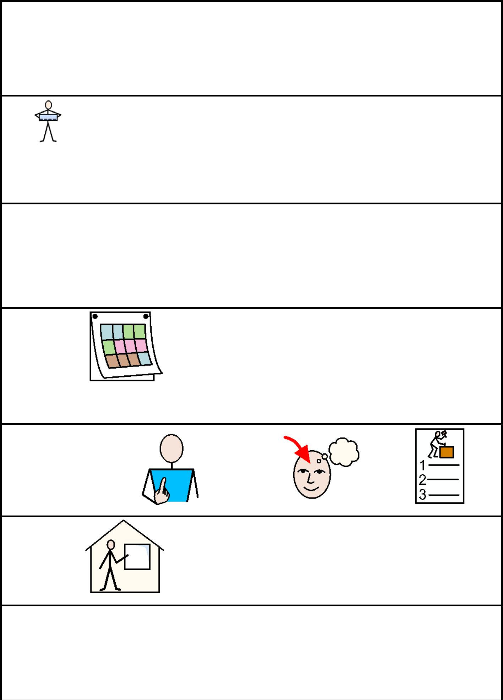

My Views

Name

Date

The Person who helped me fill this in was:

1
Guidance in completing the Pupil Voice section of the PEP for pupils with SEND

- Documentation is aimed at providing an opportunity for pupils to express their views of their progress and educational experiences.

- This resource includes a number of documents to be used to elicit the views pupils with SEND. In addition mainstream PEPs are available. Schools may wish to select those they feel are most appropriate to the needs of individuals.

- Schools may need to consider if any specialised or personalised communication aids or other specialist equipment is required either by the pupil or others who are to attend the meeting

- Schools may wish to include examples of pupil’s work or photographs, as part of their pupil voice and educational progress documentation

- If pupils have a ‘Pupil Passport’ or similar documentation this could be used to reflect pupil’s views where appropriate.

- Schools may need to consider if it is appropriate for pupils to attend some or the entire PEP meeting, depending on individual circumstances, if pupils wish to do so.

2
Talking about School
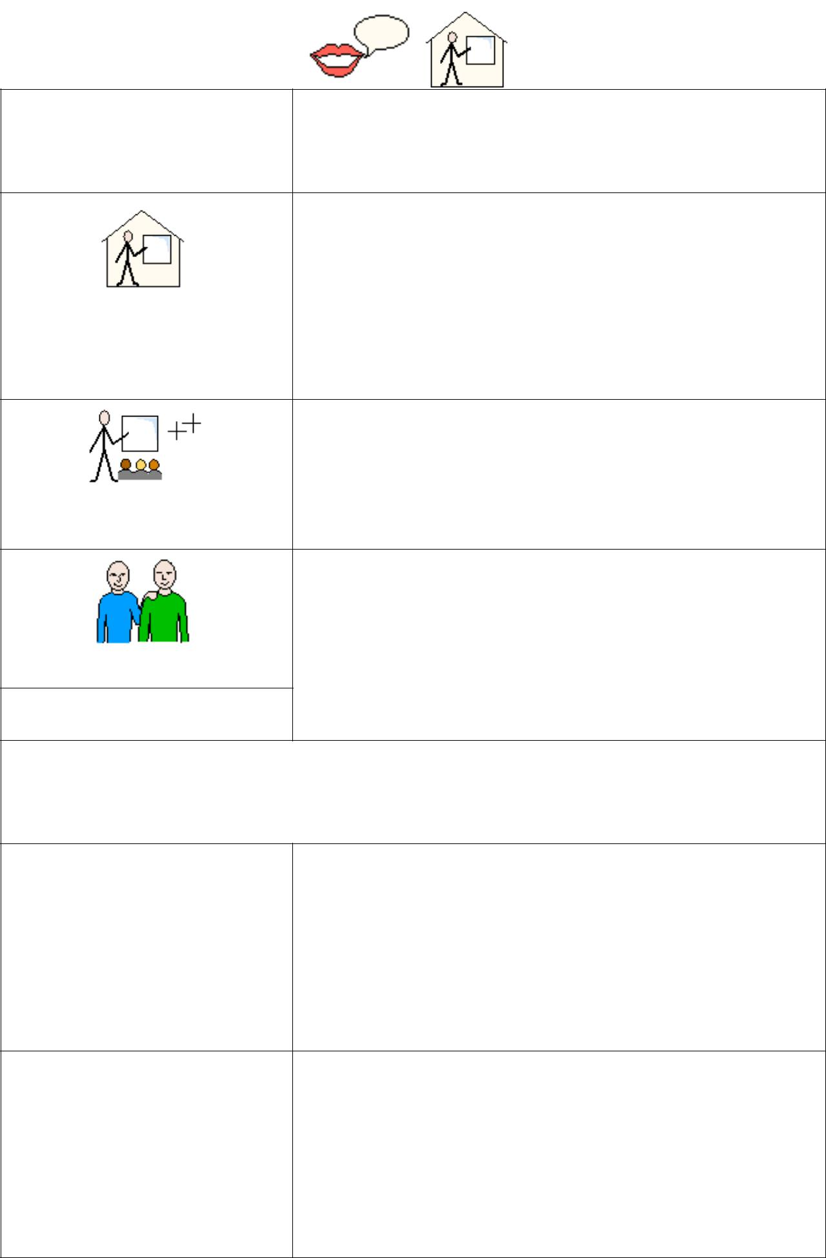

Me

(Insert photo)

School

Lessons

Friends

My School Work

Things I have done

well

Things I could

improve on

3
Things I like

Things I don’t like

Things I do out of

school/class

4
Pupils may wish to include information from their Pupil Passport or other such documentation. Photographs of examples of work etc can be pasted into boxes

Highlights from my School Work


5

Highlights from my School Work


6
This is me (1)

How I feel about school:



How I feel about reading and writing:

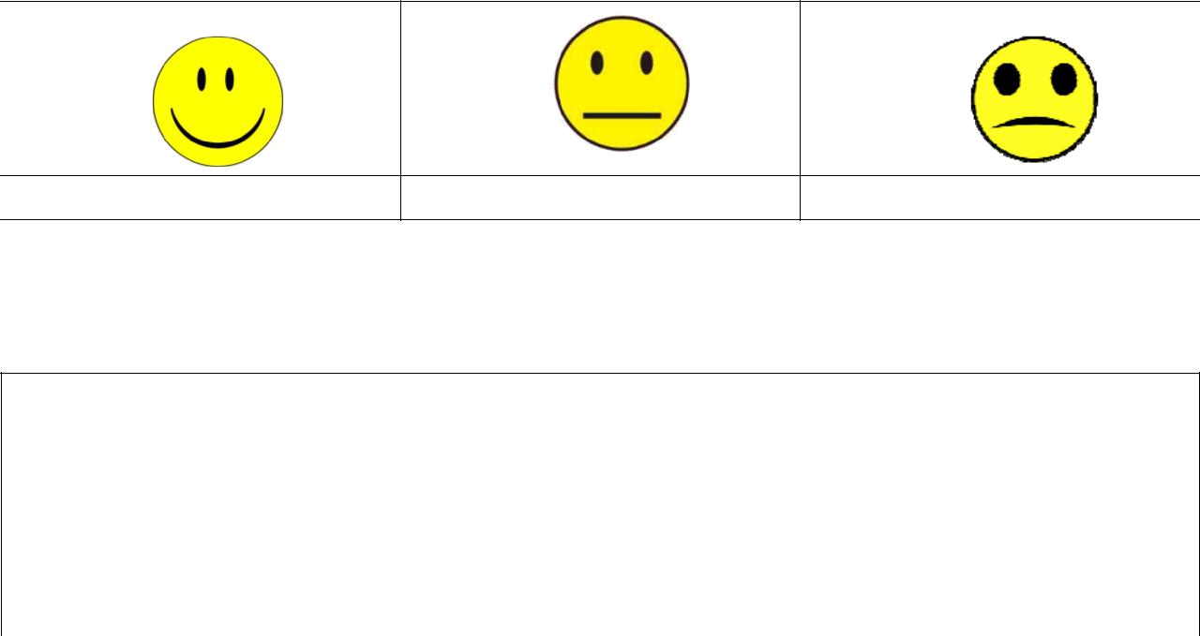

How I feel about maths:

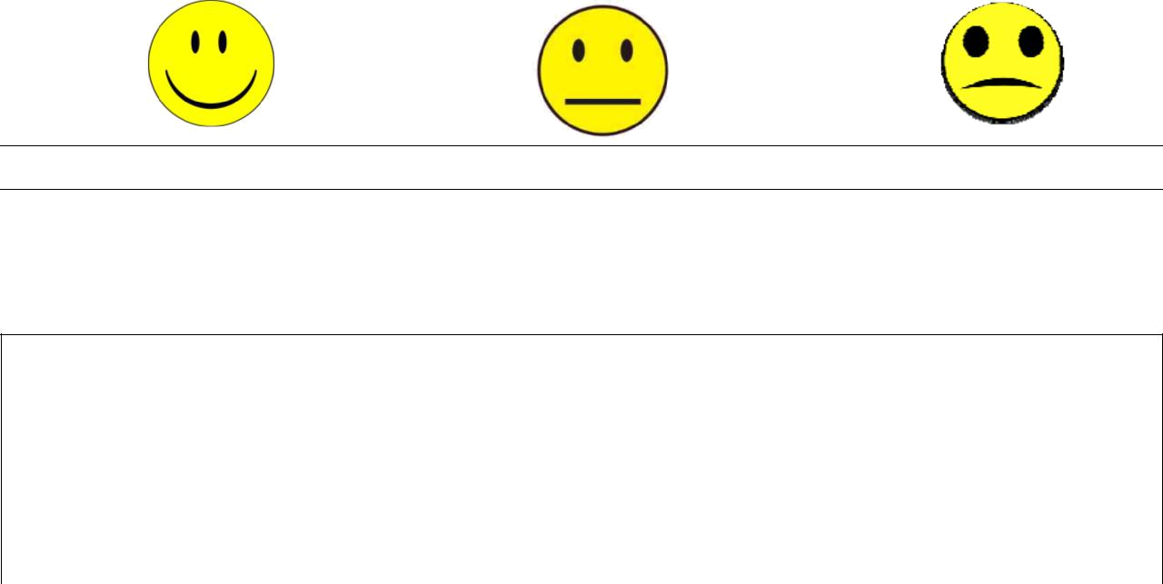

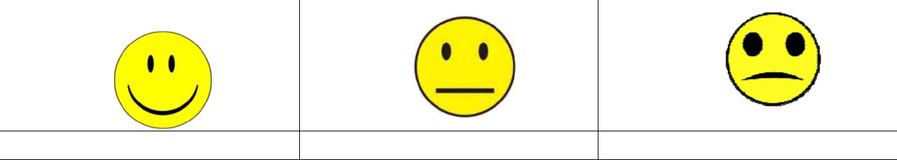
How I feel about where I live:


7
This is me (2)

How I feel about school:

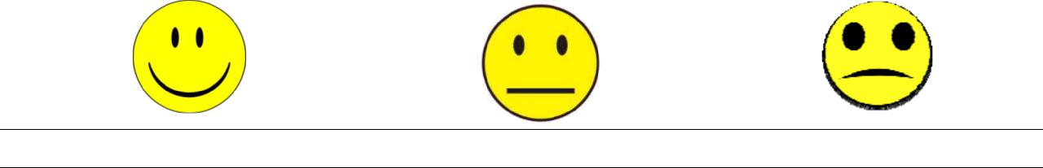

I would like my teachers to know…

How I feel about reading and writing:

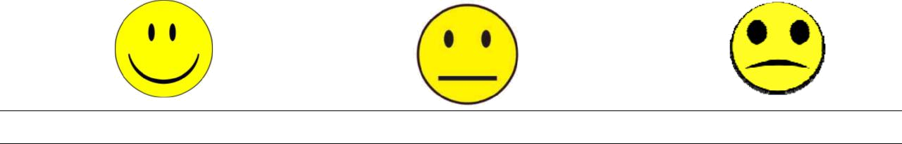

I enjoy/don’t enjoy reading and writing because…

8
How I feel about maths:



I enjoy/don’t enjoy maths because…

How I feel about where I live:

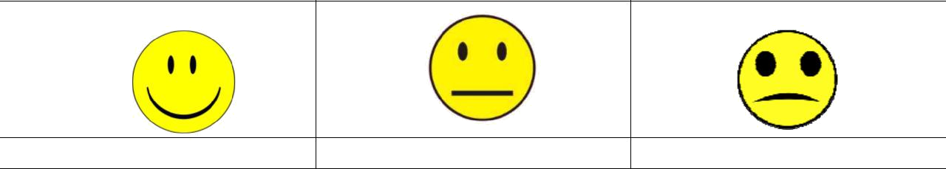

I feel this way because…

9
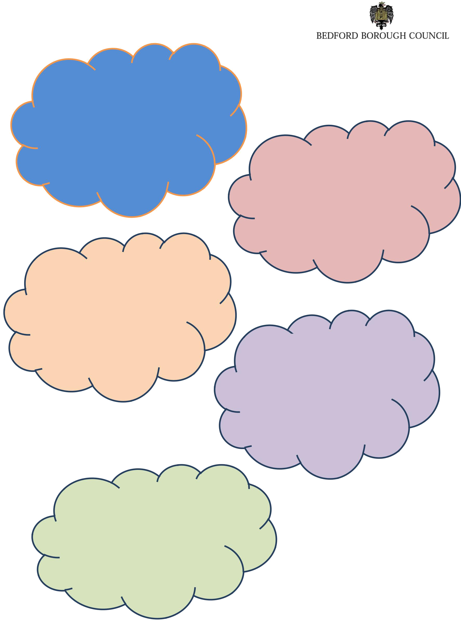

Things that I am good at:

Things that I would like help with:

I am happy when:

Things that I don’t like:

I can talk with:

10

