Moving Class

A Transition Workbook for Pupils at …………………School

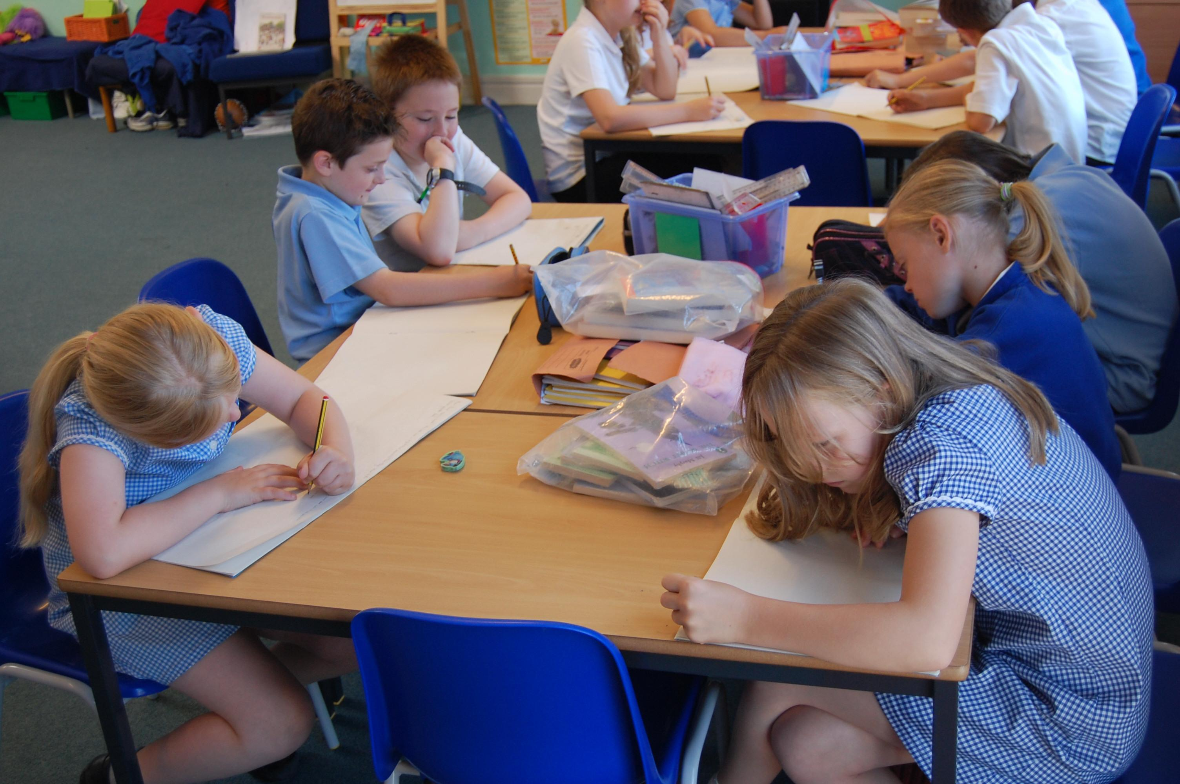

NAME:

After the summer holidays you will be moving to a new class. This booklet will help you find out about your new class.

What will my new class be like?

This booklet will help you to find out about your new class
You will probably have lots of questions that you want to ask about your new class.

Think of some questions about your new class and ask an adult to write them in the box below.

My Questions

Tick the questions when you have found out the answer.

Facts about your new class

Find out and fill in the answers...

In September I will be in Year .........

My class will be called............................................

My class teacher will be..............................................

My teaching assistant(s) will be?
…………………………………………………………………………..........................

Tick when you have found out the answers to these questions?

Where is your new class?
Where do you wait to come in, in the mornings or after play?
Where will you put your coat?

Where will you put your lunch box?


Where will you put your book bag?

Staff

Ask if you can take a photo or draw a picture of your new teacher and teaching assistant(s). Write their names underneath

Being Ready

What things will you need to take to school every day?
Draw or list them in the rucksack below.

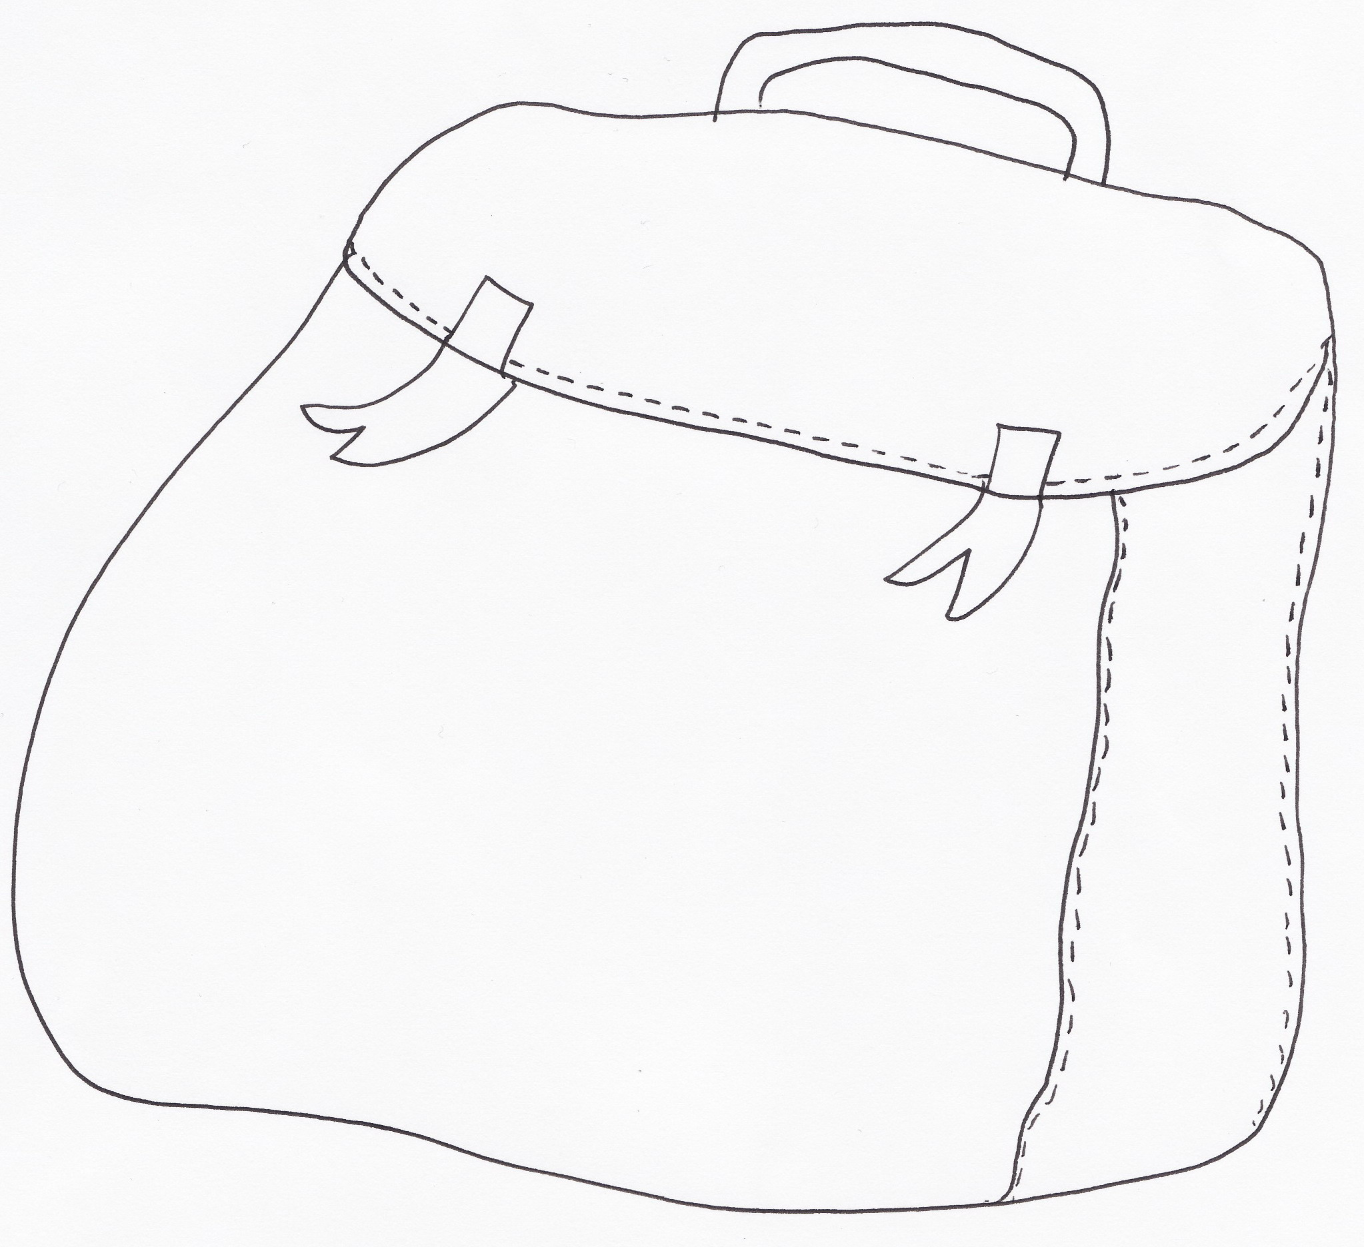

When?


When is your first day in your new classroom?

..............................................................................

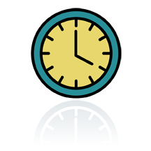
What time will you need to arrive at school?

.................................................................................


What time will you go to lunch?

..............................................................

What time will you go home?

..........................................................

Joining In

There might be new or different clubs and activities for you to try in your new class.
Make a list of the sorts of things you are interested in or enjoy doing now;

- -
- -
- -
- -
- -

You might be able to join some new school clubs or be going on some exciting visits in your next class. Find out and make a list below.

- -
- -
- -
- -
- -

Homework

You will still be able to be a Reading Star in your new class by reading at home. You will also have some homework to do. Don’t worry though because it will not be too hard. Your teacher will tell you what the homework is .

Fill in the chart below that shows when you will get your homework

Monday | Tuesday | Wednesday | Thursday | Friday

Rules

There might be new rules in your new class. They will be a bit like the rules your class has now. Sometimes the teacher will ask the class to help decide what the rules should be.
Can you write down your ideas for good rules in your next class?

1.

2.

3.

It is important that you know what the rules are and what happens if you break them.

Discuss what might happen in the following situations;

- You forget to do your homework and the teacher asks you why you haven’t handed it in.

- You don’t know what to do

- You keep shouting out or are too noisy in lesson time.

- You forgot to bring your PE kit.

Remember

Moving on to a new class is a normal part of growing up and lots of people will be there to help you.

Don’t forget to say goodbye and thank you to your teacher and the people who have helped you at school this year !

Enjoy your new class!

