

Requirements for Transferring Archaeological Archives

**2022 - 2023**



***Contents***

**Introduction 4**

**Contact Information 4**

**Documentation 5**

Notification and Contracts 5

‘Blank’ Sites 5

Building Records 6

Transfer of Title 6

Shared Title 7

Copyright 7

Documentary Archive 7

Photographs 9

**Digital Archive 10**

Depositing Digital Archives with a Trust Digital Repository 10

Content and Coverage 10

Digital Archive Preparation 10

General Guidance for Deposition with the ADS 11

Data Management Planning 12

Selection, Retention and Discard Policy 12

‘Negative’ Archive 12

Licencing, Copyright and Intellectual Property Rights 12

Data Protection 13

Fees and Charges 13

Depositing Digital Archives with the Museum 13

**Human Remains 15**

**Material Archive 16**

Digital Listings of Registered Finds and Bulk Boxes 16

Coding Bulk Boxes 17

Conservation Requirements 19

Packaging 19

*Bulk Boxes 19*

*Plastic Boxes 21*

*Polygrip Bags 21*

*Labels 21*

*Unboxed Items 22*

Hazardous Materials 22

**Selection and Disposal 23**

Museums Service Deposit and Retention Strategies 23

Excavator Collection, Selection and Retention Strategy 23

*Unstratified Material 24*

*Stratified Building Material 24*

*In-Situ Building Material 24*

*Industrial Waste 24*

*Unworked Material 25*

*Analysis Samples 25*

*Unidentifiable Animal Bone 25*

*Modern Pottery (19th to 20th century) 25*

*Modern Unstratified and Surface Finds 25*

Retention by the Depositor 25

###### Depositing the Archive at the Museums Resource Centre 26

Charges 27

Museum Retention 28

### Bibliography 29

### Appendices 30

### Oxfordshire Museums Service Collecting Policy for Archaeology 30

### Ashmolean Collecting Area Within the City of Oxford 31

### Notification of Fieldwork Form 33

### Oxfordshire Museum Service Contract 35

### Price List 36

### Transfer of Title Forms 37

### Sample Spreadsheet File for Recording Finds Information 41

### Required Information for Bulk and Finds Bags 42

### Suppliers 45

**Summary Spreadsheet of Archive boxes to be deposited. 48**

### 

### 

###### Introduction

The Oxfordshire Museums Service (referred to in this document as ‘the Service’) forms part of Oxfordshire County Council. The Service aims to preserve and promote the county’s heritage and identity, actively contributing to community engagement and place shaping.

All archaeological archives (the excavated objects, paper and digital archives) are unique records of the people and places of Oxfordshire. The aim of these guidelines is to enable us to preserve as much of the information relating to the archive as possible and provide access to the broadest range of people.

The Service recognises that good communication is key to ensuring access to and deposition of archaeological archives and we welcome and encourage regular contact. The procedures outlined below, and the accompanying charges are to ensure that professional archaeologists, researchers, students and the general public will all have the best possible access to the results of archaeological fieldwork in Oxfordshire.

The term ‘Depositor’ refers to the units or organisations depositing archives as a result of archaeological fieldwork. The Service is the repository for all archaeological archives in Oxfordshire and the deposits are made at the Museums Resource Centre in Standlake.

###### Contact Information

Museums Resource Centre

Cotswold Dene

Standlake

Oxfordshire

OX29 7QG

**Curator of Archaeology:** Angie Bolton

01865 300557

angie.bolton@oxfordshire.gov.uk

**Collections Manager:** Christiane Jeuckens

01865 300937

christiane.jeuckens@oxfordshire.gov.uk

**Registrar:** Tracy Turner

01865 300557

tracy.turner@oxfordshire.gov.uk

**Curatorial Assistant (Archaeology):** Naomi Bergmans

01865 300557

naomi.bergmans@oxfordshire.gov.uk

**Curatorial Assistant (Archaeology):** Lindsey Smith

01865 300557

[lindsey.smith@oxfordshire.gov.uk](mailto:lindsey.smith@oxfordshire.gov.uk)

###### Documentation

**Notification and Contract**

It is the responsibility of the Depositor to inform the Service of any archaeological work taking place in Oxfordshire within a month of fieldwork starting (rather than during the tendering process) by completing a Notification Form (Appendix 3) and emailing it to the Curatorial Assistants.

A separate Notification Form should be completed for each distinct archaeological site, but a new accession number need not be requested for subsequent phases of work at a site which has already been notified. In that case, a courtesy email should be sent to the Curatorial Assistants, who will make a note of subsequent phases on the existing forms.

Excavating staff are encouraged to contact the Service to arrange a meeting with the curatorial staff if a particularly large or significant archive is expected, if any problems are anticipated, or if the Depositor is new to the area. Please also contact the Service if you feel you have a valid reason for wishing to diverge from the requirements or need any of them clarified.

Once the Curatorial Assistants have received the Notification Form, a unique Museum Service accession number will be supplied. The accession number will serve for the entire site archive, including the initial and any subsequent phases of work at the site as mentioned above. The Depositor should use this code on all digital and paper records, quote it on all subsequent correspondence and in all reports and publications concerning the site, and must mark all packaging with it.

Together with the accession number, the Depositor will be sent a Contract (Appendix 4) and two Transfer of Title forms. The Contract should be signed and returned immediately. The Transfer of Title forms are for the Depositor (documentary archive) and the Landowner (finds archive) and should be returned to the Archaeology Assistants at least four weeks before the agreed deposit date.

The Service accepts appropriately excavated, recorded and presented archives relating to archaeological fieldwork carried out on sites within the county, as stated in the Museum Service’s Collecting Policy (Appendix 1). The Ashmolean Museum will sometimes accept archives relating to a site owned by the University or complementing an existing collection (listed in Appendix 2). Please consult the curatorial staff if you are unsure where your archive should be deposited.

Transfer of the archive will be conditional upon the fulfilment of the conditions of the Contract, and the correct presentation of the archive.

**‘Blank’ Sites**

In cases where accession numbers have been issued for sites which, on investigation, reveal no archaeological record of any kind, the Service needs to be informed with a one-page report detailing the location, dates of the project and stating that no archaeology was found. This report may be deposited at no charge and will be filed for internal use by the Service and the accession number will be cancelled. If a site is found to be blank before notifying the Service of any fieldwork, there is no need to then contact us requesting an accession number.

**Building Records**

It should be noted that the Service no longer collects building records unless they contain a component of material culture or are part of a larger project. Purely documentary buildings records should be deposited at the Oxfordshire History Centre, who publish their own deposition requirements: <https://www.oxfordshire.gov.uk/cms/content/depositing-documents-history-centre>

Email: oxhist@oxfordshire.gov.uk

**Transfer of Title**

In English law all material collected in archaeological projects (except material covered by the Treasure Act 1997 and human remains) belongs to the Landowner. **Finds can only legally be transferred to the Service with the written permission of the Landowner.**

To aid the process of obtaining a signature and avoid difficulties later on in the process, Depositors should notify Landowners at the point when they first contact them about the project, that the authorised repository for the archive is the Service and to obtain their agreement in principle to deposit. Depositors should inform the Landowner that the Service will write to them to acknowledge the Transfer of Title and any material donated.

Transfer of Title should ideally be established during the initial stages of fieldwork, and a detailed list of finds sent to the Landowner upon completion of work. If the Landowner will not sign the Transfer of Title until work is completed, the Depositor should contact the Landowner before transfer to the Service including a Transfer of Title form and a detailed list of finds for their inspection.

The Landowner should sign and date the form, *retaining the receipt copy* and returning one copy to the Depositor. The person signing the Transfer of Title form must be the Landowner or, where the Landowner is an organisation rather than an individual, their legal representative. The person signing must print their full name, as well as provide a signature. The Landowner’s address must be filled in and be legible. If a legal representative is signing on behalf of an organisation, they must also state their role and the name of their organisation.

The completed Transfer of Title remains with the archive until it is deposited with the Service.

If contact with a Landowner has been lost and they have not responded to your attempts to contact them, email evidence of these attempts to the Curator. The Depositor should then contact the Curator of Archaeology, providing as much detail as possible so that the risk posed by collecting an archive without transfer title may be evaluated prior to a decision being reached on whether to accept it or not.

If the deposition of the archive is agreed under these circumstances, proof of delivery for at least one letter to the Landowner and any returned letters should be included with the archive. Any replies received after deposition should be forwarded to the Service.

Please note that the terms ‘deposit’, ‘long-term loan’ or ‘permanent loan’ have no legal meaning and the Service cannot accept deposits on these terms.

### Shared title

Every reasonable effort must be made by the Depositor to keep archaeological archives intact and complete, and this includes persuading the Landowner of the merits of transferring the full finds archive to a Service. If the Landowner nevertheless chooses to retain a selection of finds, the Service may not be prepared to accept the remaining material. If the Service does accept the archive, a clear list of finds kept by the Landowner must be included in the documentary archive, together with the Landowner’s contact details. If the Landowner has decided from the outset of the project to retain all finds, the usual notification procedures should still be followed, excluding the Transfer of Title for finds. The contract and documentary Transfer of Title should be sent to the Curatorial Assistants at the earliest opportunity, and the full documentary archive should be deposited at the end of the project.

# Copyright

The Service must be informed of any restriction of copyright that may apply to the archive. A license allowing retention of copyright to the documentary archive by the Depositor, but permitting usage by the Service, is incorporated into the deposit contract (Appendix 4).

Where archaeological archives contain illustrations and/or photographic material, the Depositor can retain copyright of the images, provided that the Service can use them for any purpose under licence and acknowledging the Depositor.

###### Documentary Archive

Where practicable, digital files should be printed out and deposited as hard copy. The archive should be prepared to the minimum acceptable standard defined by English Heritage (1991 & 2006), and following guidelines detailed by Brown (2011).

Principal components of the documentary site archive (the digital material is discussed later):

|  |  |  |
| --- | --- | --- |
| **Component** | **Notes** | **Deposition requirements** |
| Transfer of Title | Must be deposited | Paper copy required |
| Contract | Must be deposited | Paper copy required |
| Site location plan(s) | Must be deposited | Paper copy required  Digital copy *appreciated* |
| Survey data | Must be deposited | Digital copy required |
| Site abstract | Must be deposited | Digital copy required |
| Context records | Must be deposited | Paper copy required and a scanned version. |
| Context register/index | Must be deposited | Paper copy required  and a scanned version. |
| Trench record(s) and other site record sheets | Must be deposited if generated by project | Paper copy required |
| Site drawings, including geoarchaeological transects | Must be deposited if generated by project | Paper or digital copy, as *appreciated* |
| Plans, sections & other drawings registers | Must be deposited if generated by project | Paper copy required  Digital copy *appreciated for registers* |
| Context matrix | Must be deposited if generated by project | Paper copy required |
| Site notes and diaries | Must be deposited if generated by project | Paper copy required |
| Fieldwork photographs | Must be deposited if generated by project | Paper or digital copy, as appropriate |
| Reports | Must be deposited | Paper copy required  Digital copy required |
| Publications | All publications relating to the site must be deposited | Paper copy required  Digital copy appreciated |

Originals and/or copies of all paper records compiled during the project must be included in the paper archive, including all text, for example project and sampling strategies, photographs and drawings such as the original trench plans and section drawings. Site report versions of these drawings are not acceptable as the primary site record.

The archive should also include the post-excavation documentation such as interpretative plans, artefact analyses, conservation records and publication drawings.

Site records and post-excavation records should be stored in archival flat document boxes with external dimensions of either 400 x 270 x 75mm or 400 x 270 x 45mm (for details of suppliers see Appendix 9).

All boxes, folders, slide carriers and envelopes must be **marked with the Museum Service accession number and/or the Depositor’s site code**, as should all documents, context sheets, etc.

Within the boxes, documents and photograph envelopes should be held in archival file folders, and the site details should be written on the box in a standard format (seeAppendix 8) using a medium permanent marker such as Staedtler Lumocolor 317.

The first archive box must include a list of contents for the documentary archive, a clear list of all the finds in the artefact archive and lists of finds that have been retained by the Landowner or otherwise dispersed. There must be indexes for all parts of the documentary archive.

Large site plans and section drawings should be deposited with a strong adhesive plan hanging tape to be hung in a four prongs cabinet. The adhesive tape should have the accession number written on it, ideally on the right-hand end. If the plan is small and can be rolled to fit in the document archive box, then please do so.

Reports need to be bound, their pages numbered, and a summary included at the front. Illegible or unclear reports or records will not be accepted for deposit. Waterproof and lightproof ballpoint or rollerball pens (e.g. Uniball Micro deluxe) or pencil must be used, and all records must be clearly marked with site name, site code and date.

Recycled paper has a short lifespan and is not recognised as permanent for archival purposes.

Where papers need to be fastened together this should be done using plastic treasury tags or plastic paperclips. Metal fastenings of any sort should not be used.

### Photographs

Negatives, contact prints and original photographs should be provided in suitable acid-free archival sleeves. Silver safe-type paper envelopes are ideal storage media for negatives and x-radiographs, although the use of polyester packets may be more practical. Each envelope must be marked with the Museum Service accession number.

Photographs should be classified by type of media, with negatives, prints, transparencies, x-rays and others categorised separately.

Each photograph should be marked on the back with the Museum Service accession number and the Depositor’s site code, object identifier (if appropriate), film and frame number, using a soft pencil.

All photographs should be accompanied by a photographic index.

Slide mounts should each be labelled with a unique number which links the slide to the archive – this must be in the following format:

|  |  |
| --- | --- |
|  | **[accession number] / [film number] . [slide number]** |

e.g. OXCMS: 2003.12/12.1. Alternatively, a number utilising the site code may be used instead, for example OXSMR03.2/2.

All metal objects (other than finds designated ‘frag’, ‘scrap’ etc) MUST be accompanied by x-rays processed to archive standards deposited with the site archive. These x-rays are required for ongoing conservation monitoring as well as object identification.

If not depositing images with the Archaeology Data Service, digital photographic images should be in either TIFF or JPEG format (if JPG the compression ratio should not be so high as to degrade the image quality).

Digital photographs should be included on archival standard gold CD-R or DVD-R inside a rigid jewel case marked with the Museum Service accession number and site code.

###### Digital Archive

# Depositing Digital Archives with a Trusted Digital Repository

Museums that are not specialist digital media repositories are advised to ensure that digital archives are stored in trusted digital repositories (Brown, 2011), the Service is not such a repository. The Archaeology Data Service (ADS) is a Trusted Digital Repository and currently the only Core Seal Trust accredited body in the UK which receives archaeological archives. Deposition with a subject-specific, open repository such as the ADS not only secures information for posterity, but increases the exposure of data to relevant audiences, increasing the likelihood of discovery and re-use. Furthermore, long-term preservation to enable the discovery and re-use of data is now a recognised and desired outcome for project funders including research, the National Lottery Heritage Fund, and national heritage agencies.

In 2018 the Service expressed the intention to require that Depositors deposit their digital archives with the (ADS). The Service does not have the expertise, capacity or resources for the long-term preservation and curation of born-digital data resulting from fieldwork projects but appreciates that for older sites this was not budgeted for by Depositors, therefore the Service will accept this digital data for sites with accession numbers up to, and including 2018.

For accession numbers from 2019 onwards, the Service is working in partnership with the Archaeology Data Service (ADS) to ensure the long-term preservation and curation of digital material from excavations, therefore you will also need to deposit the digital archive with the ADS.

As best practice we would strongly urge you to deposit digital archives with the ADS which have accession numbers prior to 2019 but appreciate there may be financial constraints for you in doing so.

### Content and Coverage

All born digital material should be included in the digital archive (Brown 2011, CIfA 2014). Content of digital archives will reflect the significance of the heritage asset(s) under investigation. In general, this will be reflected in the intensity of investigation conducted.

For example, open area excavations or excavations of deeply stratified remains will often record significant archaeological remains and involve the production of a rich digital archive encompassing material including, but not limited to, excavation and post-excavation reports, specialist (e.g. finds and environmental) databases, digital photography, plans, sections and maps (CAD/GIS), context databases and matrices. Equally, investigations yielding little or no significant archaeological features or finds will generate fewer of these categories of data. You should be clear as to the appropriate content and coverage of your collection and plan for deposition accordingly.

### Digital Archive Preparation

A summary of the digital archiving process can be found in Figure 1.

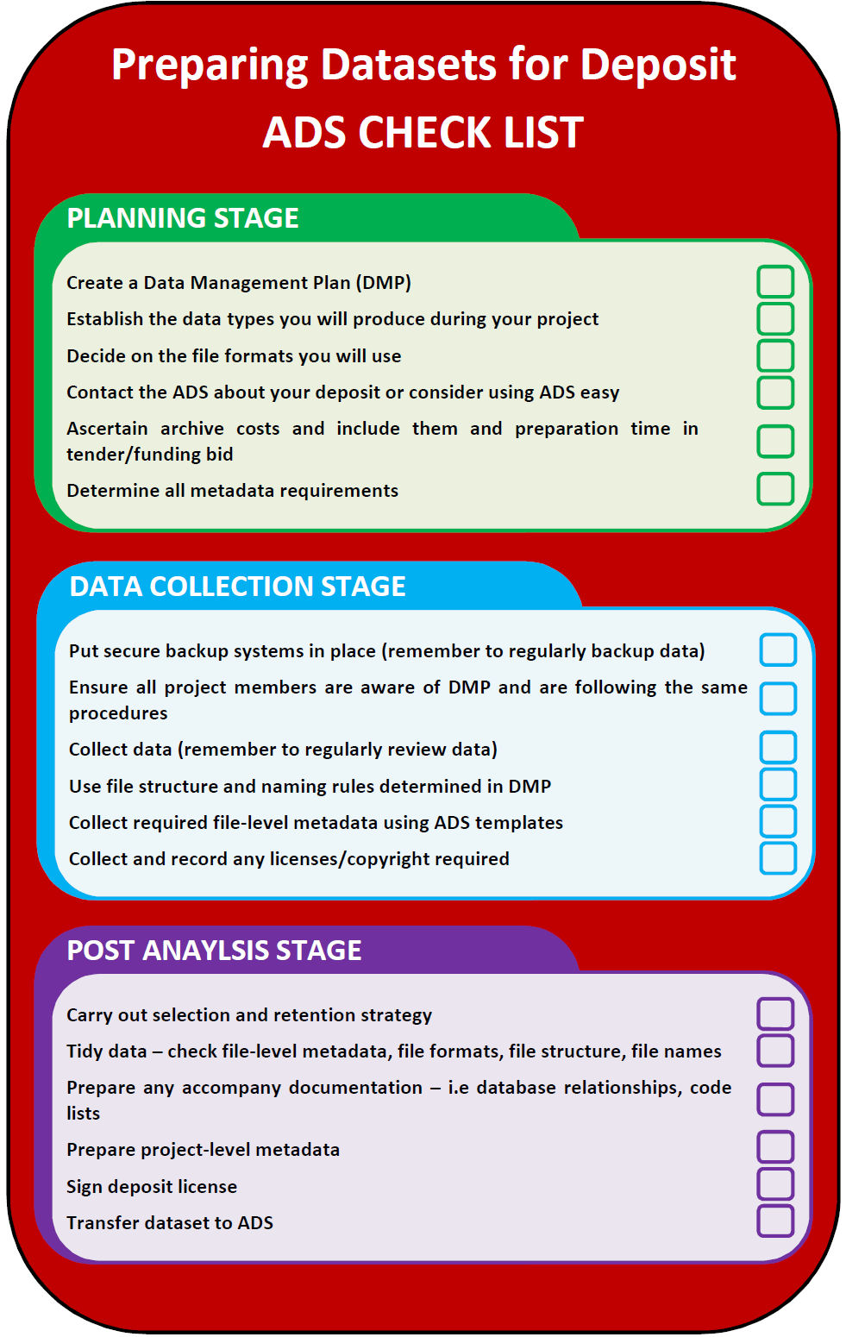

Figure : Summary of the Digital Archiving Process (Source: Society of Museum Archaeology)

### General Guidance for Deposition with the ADS

The content of the digital archive should be appropriate to the nature of the investigation and guided by current professional best practice as stipulated by CIfA (CIfA 2014) and the ADS. For datasets where the content of the archive is unclear, or where data types are not covered by that guidance, those depositing data are urged to consult the Museum Service and the ADS (2015). Archives should be prepared for deposition with the ADS in accordance with their [Guidelines for Depositors](http://archaeologydataservice.ac.uk/advice/guidelinesForDepositors.xhtml) and with reference to their [Guides to Good Practice](http://guides.archaeologydataservice.ac.uk/) where appropriate.

Potential depositors with the ADS should contact them about their digital archive deposition as soon as a project starts in Oxfordshire.

### Data Management Planning

The Service offers no specific guidance for data management planning and readers are at liberty to choose their preferred methods. Good data management will ensure the security, longevity and access to and understanding of data from capture, creation to deposition with an archive repository. It will also ensure the smooth transition of material from archive creator(s) to the ADS.

As a bare minimum, digital storage media should be kept in conditions that minimize risks of damage, deterioration, loss or theft. Digital files should be regularly backed up throughout the course of a project. **The Service strongly advises that the ADS guidelines regarding software, formats, metadata and file naming are consulted to prior to files being created/captured, in order to minimise any further work required to prepare your digital archive for deposition with the ADS at the end of the project.**

Version control must be maintained so that it is possible to identify the most up to date version of a file (only the most up to date/correct version of files should be deposited). Duplicate and poor-quality files (for example poor focus/light or duplicate digital photographs) should be removed before transfer to the ADS.

### Selection, Retention and Discard Policy

All deposits should be checked for duplicate or draft versions of files, and these should be removed. Poor quality and/or duplicate images should not be deposited. Where any further selection and retention strategies are planned in relation to digital archives, agreement with the Service and the relevant HER/Planning Archaeologist will be required.

### ‘Negative’ Archive

Where sites result in an archive of limited research benefit or re-use potential (for instance where no features or finds are recovered), and it is proposed to discard the digital archive material, this should be agreed with the Service and the relevant HER/Planning Archaeologist.

The final grey literature report should be deposited through OASIS.

### Licencing, Copyright and Intellectual Property Rights

You should establish ownership and copyright of your data at the project’s outset and obtain any written consents necessary for you to be able to sign the ADS deposit licence. Copyright of digital data handed to the ADS is retained by the copyright holder, but depositors must grant the ADS a non-exclusive license to preserve and distribute a collection. Work cannot start on digital preservation until a deposit licence is signed, and this can cause delays to projects in extreme cases.

Copies of the ADS Deposit License can be found here under the downloads section <http://archaeologydataservice.ac.uk/resources/attach/ads_licence_form.pdf>

To maximise the value and re-use potential of collections, the ADS recommends that users agree that their data be distributed under a creative commons attribution licence (CC-BY) <https://creativecommons.org/licenses/by/4.0/>

### Data Protection

Ideally, you should ensure that any digital data transferred does not contain personal information. If this is unavoidable, it is your responsibility to ensure you are compliant with the General Data Protection Regulation (GDPR) and all fair processing notices have been given (and/or, as applicable, consents obtained). See <https://ico.org.uk/for-organisations/guide-to-the-general-data-protection-regulation-gdpr/> for details on GDPR.

### Fees and Charges

Potential depositors should consult the ADS [Guidelines for Depositors](http://archaeologydataservice.ac.uk/advice/guidelinesForDepositors.xhtml) for information about depositing as early as possible during a project, preferably at the tender stage so that digital archiving costs can be accommodated in project timescales and budgets.

Details of the ADS Charging Policy are on their website: <http://archaeologydataservice.ac.uk/advice/chargingPolicy.xhtml>

A cost calculator for small projects (fewer than 300 files of standard types) is available at: <http://archaeologydataservice.ac.uk/easy/costing>

Fees are paid directly to the ADS for deposition of the digital archive. Depositors were forewarned of this in the 2019 Requirements for Transferring Archaeological Archives.

**Depositing Digital Archives with the Service**

It should be reiterated that the Service is not a specialist digital media repository and as such, where possible, Depositors are advised to ensure that their digital archives are stored in trusted digital repositories (Brown, 2011). However, where digital files exist for sites where the Museum Service’s accession numbers date up to and including 2018, depositing this archive with the ADS may not be an option. Instead the files can be supplied to the Service as part of the archive. These may include CAD files, databases, digitised data such as context sheets, geophysical and other survey data, GIS files, spreadsheets and text files and should be in an open access format where possible. These files will be given the available resources of the Service and able will be stored for as long as possible, but not in perpetuity and they will not be curated.

The Service requires the details of the hardware and software used to generate digital records and a digital index must be complied with and deposited with the archive. For the born digital and digitised material being deposited with the Service, we ask you to compile the digital archive to ADS standards, using consistent file-naming and folder structure conventions and adding metadata and likewise for any digitised data. The archive would then be fit for transfer to ADS if such an opportunity arose.

Database information may be deposited on open access software compatible with Microsoft Excel.

All digital files should be provided on gold/gold archival standard CD-R or DVD-R discs and placed in rigid jewel cases and labelled with the Museum’s Service accession number using a permanent marker, not a sticky label.

###### Human Remains

If human remains make up part of the archive then the exhumation licences must be included in the document archive. If human remains were excavated, but are not being deposited, please include a document to explain why not.

Human bones should be individually marked with a skeleton ID number and, where possible, the site code as prescribed by DCMS (DCMS, 2005:19).

Skeletal material should be packed in boxes measuring 600mm x 250mm x 250mm since this size can safely accommodate long bones. The skull should be included in the same box as the rest of the skeleton, if it can safely be stored in this way. Alternatively, skulls may be boxed separately in boxes measuring 250mm high x 200mm x 200mm, if there is not enough space to safely pack them with the long bones. If multiple boxes are used for one individual these should be numbered 1/3 etc.

The base of the boxes should be lined with padding, for example polyethylene foam and acid free tissue, but not bubble wrap. Padding of acid free tissues nests should also be used so as not to allow the bones and bags of bones to move within the box.

Human remains should be packed so that different individuals can be distinguished from each other.

The remains should be packed in order of stability, with heavier bones beneath more fragile material.

The bones should be placed in strong self-seal polygrip bags which are large enough to be sealed. For the long bones if polygrip bags are not available, place in a clear, strong bag and seal it with string or cotton tape, notmetal ties as these corrode.

If the terminal of a long bone is damaged, to protect the internal matrix of the bone, wrap the terminals in soft (not ‘crunchy’) acid free tissue to prevent further damage. Acid free tissue should also be used if the bone is burnt.

The bones of hands and feet should be placed in a single bag for each, separate extremity (e.g. bones of the right hand in one bag, those of the left in another).

The ribs can be placed in a single bag, but the bag must be strong and large enough for the ribs to fit comfortably within the bag and not pierce it.

The skull, maxilla and mandible should be at the top of the box placed on a nest of acid free tissue (if not boxed separately – see above). Loose teeth, maxillae and mandibles should be bagged separately, not placed inside the cranial vault. Pathological bones and fragile maxillae and those with teeth remaining should also be cushioned with acid free paper.

###### Material Archive

For small finds and metalwork, there must be a unique numbering system for the whole site, covering all areas, trenches and seasons of excavation. Small finds numbers must be unique. Please ensure that, in the case of sites excavated in multiple phases, context and finds numbers are sequential, following on from previous phases of excavation so that these numbers are not duplicated.

All individual non-metallic registered finds (those with an individual small find number within a triangle) should be marked in indelible black ink on the back, or in the least disfiguring spot, with *either* the site code and unique small finds number *or* **preferably** the Museums Service’s accession number for the site and the small finds number. Please contact the Service if you would like advice about marking finds.

**Digital Listings of Registered Finds and Bulk Boxes**

To help with the accessioning of site archives containing more than 20 registered finds, the Service would like to receive a digital file, file email, recording the details of all registered finds and bulk boxes. This can be emailed to the Curatorial Assistants when booking a date to deposit the archive.

The format of the digital files should be of a type which provides for long-term accessibility, for example this could be in the form of a spreadsheet in CSV format (with associated metadata) consisting of one line (record) per bulk box, plus one record per registered find, including illustrated and/or reconstructed pottery and any unboxed items. The first field/cell will consist of the Museums Service accession number or Depositor’s site code, and each record should also contain the following:

|  |  |
| --- | --- |
|  | the simple name of the box’s contents or of the registered find (e.g. pottery, brooch) |
|  | the material (e.g. stone, ceramic) |
|  | the production date/period of the item |
|  | dimensions |
|  | number of items or fragments (not necessary for bulk boxes) |
|  | site context |
|  | the identifying specialist |
|  | publication reference (if any) |

Simple names are provided by the MDA Archaeological Object Thesaurus this is further developed by the Forum on Information Standards in Heritage (FISH) <http://www.heritage-standards.org.uk/fish-vocabularies/>.

The archive will not be accepted if these files are incomplete or inaccurate. A sample spreadsheet and corresponding CSV format file is given in Appendix 7. If you have a standardised format, do contact the Service to see if it meets the Service’s needs and can be used instead.

Where specialists have been employed to record pottery and bone as well as individual small finds and other classes of material, copies of any digital files created must be deposited with the archive, for example the recording grid showing contents of contexts individually identified. This is for Museums Service identification purposes only and the author/specialist retains the copyright.

The following types of material must be separately bagged and clearly identified on the bag:

|  |  |
| --- | --- |
|  | * Metal finds whose object type is recognisable, except for nails |
|  | * Worked organic objects whose type is recognisable or whose decoration is diagnostic |
|  | * Illustrated pottery |
|  | * Tile: well-preserved examples, diagnostic types, decorated and/or glazed types |
|  | * Worked flint and debitage |
|  | * Bones of rare/uncommon animals or bones which show signs of human activity e.g. butchery marks |
|  | * Pottery: whole, nearly whole or reconstructable pots; diagnostic or decorated sherds of e.g. Prehistoric or Saxon pottery, and examples illustrated in the publication |

Metal finds designated ‘frag’, ‘scrap’ etc need not be individually registered, but should be individually bagged and placed in a box coded according to the material.

(e.g. OXCMS: 2002.173.Fe for iron; OXCMS: 2002.173.CA for copper alloy).

All pottery retrieved during fieldwork that meets the Service’s Retention and Disposal guidelines (see below) should be deposited.

Any material which is of special interest for potential research or public display should be highlighted. We would be grateful if specialists clearly label bags of material with identification/classification information which will assist us in making accurate records for our database, making it a more effective tool for future researchers.

Samples removed from small finds during specialist analysis, such as resin-mounted metal sections, should be submitted with the archive. The method of packaging and labelling can be decided by the specialist, or advice may be sought from the Service.

## Coding bulk boxes

All bulk find material should be marked, where possible, with the site code and context number as a minimum. Bulk find material should be presented in self-seal polygrip bags on which the following core information is written in black permanent pen: context, material (e.g. pot, iron), date of material (e.g. 2nd century AD; *not* the date of the context), site name and site code, object name, and small finds number in a triangle (see Appendix 8 for examples).

Please ensure that the site code format is standardised: letters, space, year.

Boxes must not be overfilled and must be packed in such a way that heavier items cannot damage other objects in the box.

Please number each bulk box consecutively (e.g. AO1, B1 to B7, P1 to P20).

The following lettering system is to be used for designating boxes:

|  |  |  |
| --- | --- | --- |
|  | **A** | Documentary archive |
|  | **B** | Animal bone |
|  | **BM** | Building materials (non-ceramic, including slate) |
|  | **CA**  **CBM** | Copper alloy  Ceramic building material (brick, tile etc) |
|  | **CH**  **CP** | Charcoal  Clay pipe |
|  | **DB** | Daub |
|  | **F**  **FC**  **Fe** | Flint  Fired clay (excluding clay pipes)  Iron |
|  | **FLOT** | Flotation samples |
|  | **G** | Glass |
|  | **HB**  **L** | Human bone  Leather |
|  | **OM** | Other metal (not Fe, Pb, CA) |
|  | **P**  **Pb** | Pottery  Lead |
|  | **PL**  **PLAN**  **SHALE** | Plaster (for large sites)  Plans  Shale |
|  | **SH** | Shell |
|  | **SL** | Slag (for large sites) |
|  | **ST**  **T** | Stone  Tile (for large sites) |
|  | **W**  **WB** | Wood  Worked Bone |
|  |  |  |

If an entire site material archive, excluding human remains or material which requires specialist storage such as metals or organics, will fit into one or two full-size boxes this is acceptable. The following coding can be used:

|  |  |
| --- | --- |
| **AO**  **M**  **MM** | Organics eg. Leather, wood, worked bone, but excluding flots and animal bone.  Miscellaneous (animal bone, pottery, building material, flots, stone or flint, glass, slag, plaster, samples, other material which does not fit in to any other category or in an **AO** or **MM** box)  Mixed metal (but if a box contains predominantly one type of metal with small amounts of others, use the code for the predominant metal) |

## Conservation requirements

The Museums Service requires that:

* First aid and analytical work is complete prior to deposit
* All objects are physically and chemically stable, bearing in mind that long-term storage in controlled dry conditions will be provided for metal small finds and unstable glass; controlled conditions are provided for organic materials such a textiles, leather and worked bone artefacts; and ambient stable conditions are provided for all other bulk material.
* Wet organic materials and other organic materials are deposited in a dry and stable condition that allows them to remain so in ambient conditions.
* All objects are strong enough to be handled or have appropriate supportive packaging that allows them to be examined.
* Any conservation work carried out before deposition is carried out by an accredited conservator or in consultation with the Museums Service.
* All deposited material should be free of pests and infestations.
* All metal objects, with the exception of finds designated frag, scrap and nails must be accompanied by an x-ray processed to archive standards and deposited with the site archive.
* Finds are accompanied by x-rays, conservation records, unpublished specialist reports and digital spreadsheets listing the items (see Appendix 7)

## Packaging

Please refer to the SMA’s Material Fact Sheets for guidance accessed at <http://socmusarch.org.uk/training/smart-project/> and Watkinson’s (1998) *First Aid for Finds* for the correct approach, and to ensure that items are packed with due regard to stability and fragility.

### Bulk boxes

All bulk finds should be placed in wire-stitched archival quality cardboard boxes, with lids with a depth of at least 75 mm. Only boxes of the size 400mm x 250mm x 220mm or fractions of this size will be accepted by the Service. For suppliers of appropriate boxes see Appendix 9.

Bulk finds should be separated according to material (also see section on Coding bulk boxes). Bulk boxes may be used to house registered finds together with bulk of the same material, provided the small finds are clearly marked out and separately bagged. Larger volumes of registered finds should be boxed separately.

Please follow the following guidelines when packing boxes:

* Boxes and bags must not be overfilled, but equally boxes must not be too large as this allows the contents to move around
* Boxes should contain a unique contents list
* Boxes must contain finds from only one site
* Most bulk artefacts must be placed in perforated clear polyethylene bags no smaller than 6 x 9in.
* Lighter materials must be cushioned from heavier materials.
* Boxes containing few objects should have cushions of acid-free tissue to prevent objects from moving.
* Bags of finds should be filed in the boxes in context number order. Groups of pottery or individual vessels from one context which have been bagged separately should be filed alphabetically by identification.
* Contexts with large quantities (more than 100 sherds or a box-full) of pottery should be sorted firstly *by fabric* and secondly, if necessary, *by form*, into separate bags. Illustrated sherds or vessels should be in separate bags.
* Reconstructed pots should be in a separate box, but a proxy bag (or bags if it includes more than one context) should be filed in the box where its context and fabric sequence order occurs.
* Post-medieval glass should be separated into vessel and window glass.
* If more than one descriptor is needed on a bag label they should be arranged in hierarchical order, starting with the general and following with more specific terms e.g. for pottery that has been bagged by fabric and form the labels should read ‘*Pot*’, followed by identification of the group or vessel e.g. ‘*Samian*’ or ‘*baluster jug*’.
* Illustrated artefacts should be separately bagged and ‘*ILLUSTRATED*’ written on the label. It should also all be noted on the Finds Inventory and Box Content Sheet.
* Contexts with large quantities of animal bone (enough to fill a full-size standard box) must be sorted first by context, then by *genus* into separate bags or boxes; otherwise sort by species if possible. Please consult the Curator of Archaeology if a site produces large quantities of animal bone, as the Service may opt to retain only a percentage of the whole animal bone collection.

### Plastic boxes

Metal finds should always arrive at the Museums Service in sealed plastic Stewart boxes containing silica gel, the amount of which should be dictated by the overall volume of the box and objects it contains. Silica gel must be contained in sealed, perforated polygrip bags. Many manufacturers provide silica gel volume calculators on their websites.

In regard to worked bone artefacts such as combs, and carved shale objects, these finds should be deposited in Stewart boxes, but do not require silica gel.

All other finds, such as pottery should be in a bulk box and will not be accepted if they are deposited in a plastic box.

### Polygrip bags

Only re-sealable polythene bags with write-on panels should be used, with the site code, context number within an oval/circle or ( ), and contents description clearly recorded (see Appendix 8). Special finds numbers may be recorded in a triangle, sample numbers in a diamond shape or <>.

The bag sizes should be dictated by the size of the objects that they are to contain. Material in paper bags, or in non-resealable bags (with the exception of human remains as described above) with or without separate fasteners will accepted.

Bags containing fragile material such as metals and worked organic material may be internally padded with Jiffy foam or acid free tissue.

### Labels

All finds packing must be labelled with the Museums Service accession number.

All labels must be written with permanent ink. The larger bags may *also* be labelled with a suitable thick black permanent marker such as Staedtler Lumocolor 317. Cardboard should be marked with a reliable lightfast ink such as Edding 1800 Profipen.

Boxes should be labelled with a permanent pen or marker on one end. Write directly onto the box, not the lid, and not onto a sticky label which may fall off (except for plastic boxes). Please follow the diagram of a properly labelled box-end in Appendix 8.

Boxed items of stone, pottery, or tile which have not been placed in plastic bags must be labelled using a heavy-duty paper label tied or fastened securely around the object with string or cotton tape.

### Unboxed items

All items to be transferred should be boxed, with the following exceptions:

exceptionally large items, such as a section of mosaic pavement lifted by conservators;

lengths of original worked timber; exceptionally large pieces of worked or sculpted stone or plaster.

All worked stone that will fit in a box must be boxed.

Please construct a special box for ceramic or metal items too large to be stored in standard bulk boxes, also for fragile animal bones, antler and fossilised bones.

Large, unboxed items must be labelled with a waterproof label, marked with permanent ink and attached by a strong polyester cord.

## Hazardous materials

All hazardous materials must be notified in advance. Oxfordshire Museums Service reserves the right not to accept an archive if such materials have not been safely treated and packaged and are not accompanied by a full COSHH assessment, giving details of control measures including action to be taken in the event of accidental spillage or release.

Where safe alternatives exist, hazardous materials of Class II risk **must not** be used – this particularly applies to blue self-indicating silica gel, which will not be accepted as a packing material.

###### Selection and Disposal

The Oxfordshire Museums Service, as the formal repository for excavated material under the National Planning Policy Framework (with certain exceptions agreed with the Ashmolean Museum) undertakes in principle to preserve deposited archives in their entirety.

Where total collection and deposition is not practical for either excavator or repository and does not enhance the scientific value of the archive the Service asks excavators to observe the guidelines of the Society of Museum Archaeologists on *Selection, Retention and Dispersal of Archaeological Collections* (1993).

The site archive must detail the sampling strategies and the relevant policies, in respect of any non-collection or disposal during excavation or post-excavation work and include an account of any relevant material.

The Curator of Archaeology would welcome discussion on the retention and discard strategies with excavators at any stage of a project and is able to visit Depositors either on site or at their premises. Please contact the Curator to discuss retention criteria guidelines if large quantities of building or other materials are expected from an individual site.

## Museums Service Deposit and Retention Strategies

The Museums Service aims to retain indefinitely archaeological archives as deposited, but it reserves the right to subsequently dispose of material; this would not normally be before a period of at least five years from the publication of the archive has elapsed.

Any such disposal would observe as a minimum standard the Society of Museum Archaeologists guidelines as noted in the *Selection, Retention and Disposal of Archaeological Collections* (1993), *Guidance on the Rationalisation of Museum Archaeology Collections* (2018) or subsequent national standards and would be in accordance with the Service’s current *Collections Management Policy* and *Acquisition and Disposal Policy.*

Any materials would be offered for educational use before disposal, or to suitable registered museums in the site locality.

Disposal of material would be published in the appropriate journals (Museums Journal, Oxoniensia, CBA South Midlands) normally one year prior to disposal.

### Excavator Collection, Selection and Retention Strategy

The deposited archive must describe the policy for the collection and retention of finds both during and post excavation, and the sampling strategies adopted or specialist recommendations.

Total collection and deposition is recommended other than for:

|  |  |
| --- | --- |
| **A** | **Unstratified Material**  Unstratified material that contributes nothing to the archaeological record should not be deposited unless the object has its own inherent interest or significance (e.g. spoil heap finds which can be dated by typology/style) |
|  |  |
| **B** | **Stratified Building Material** |
|  | * Stonework Stone building material (moulded or worked stone) should be catalogued and recorded by stone type, and form type. Only complete or near complete pieces should be retained for deposition, together with examples of the various stone types utilised, any other forms, or those with traces of paint, graffiti or masons’ marks. For stonework from church sites, please liaise with the church authority before discard (other than redundant church sites). General rubble should be discarded * Ceramic building material |
|  | Should be catalogued, scanned and recorded to an appropriate archive level before selective discard. Ceramic building material should be quantified (number and weight of fragments) by type (e.g. *tegula*, *imbrex*, miscellaneous flat fragments, etc). Only complete lengths/widths should be retained, together with examples of any unusual fabrics, and any fragments with features such as ‘signatures’, stamps, decoration or imprints. |
|  |  |
| **C** | **In-situ Building Material** |
|  | * Mosaics, tiled floors, painted wall plaster: For large areas, please liaise with the Oxfordshire Museums Service and the County Archaeologist to devise a policy for recording in situ and/or preservation, or for lifting and retention |
|  | * Stone walls/structures Deposit only samples (i.e. 300-500g) of mortar, or opus signinum Catalogue moulded stones, depositing only designated type stones |
|  | * Tile, brick (other than Post-Medieval) Catalogue and discard, other than stamped or decorated fragments |
|  | * Post-Medieval brick, tile  Deposit two samples (exemplars) from each significant structure |
|  |  |
| **D** | **Industrial Waste** |
|  | * Kiln waste, waster dumps Catalogue and discard |
|  | * Slag Collect, record and sample for deposit |
|  |  |
| **E** | **Unworked Material** |
|  | * Flint Discard; weigh prehistoric burnt flint before discard |
|  | * Marine mollusc Discard other than samples of large dumps * Animal Bone   Discard unstratified animal bone |
|  |  |
| **F** | **Analysis Samples** |
|  | * Residues Residues may be deposited, but unanalysed samples only deposited with demonstrated potential for further research |
| **G** | **Unidentifiable animal bone**   * Unidentifiable animal bone should not be deposited unless it shows signs of working/butchery. Deposits should be weighed and recorded before discard |
| **H** | **Modern pottery (19th/20th century)**   * Modern pottery should be discarded unless archaeologically significant, relating to the project, or of a particularly unusual type. |
| **I** | **Modern unstratified and surface finds**   * Unstratified and surface finds of modern material should be discarded. |

Any discard policy adopted must be fully documented in the project archive and discussed with the Curator of Archaeology prior to deposition.

### Retention by the Depositor

Retention by the Depositor of type series samples from the site should occur only in consultation with the Museums Service and should be obtained from material that might otherwise have been omitted from the archive according to the above selection guidelines.

Depositors may offer the Service undeposited material for educational use.

Any finds not covered by disposal guidelines which are kept by the excavators with the agreement of the Museums Service will be considered as loans and will be administered by the Registrar.

###### Depositing the Archive at the Museums Resource Centre

Before deposition we will need a clear indication of how many boxes will be deposited so we can make sure we have enough space in the store to receive the deposit. At this point, Depositors should ensure the following:

* The Project archive is complete
* Transfer of Title forms and Contract are completed and signed
* Records are correctly grouped and packaged
* Records are digitally scanned and filed as if they were being deposited with the ADS if the accession number is prior to 2019.
* Records are being deposited with the ADS for sites with accession numbers from, and including 2019.
* Archaeological material is appropriately bagged, boxed, documented and checked
* Archaeological metalwork, where appropriate, has been X-rayed and these included in the records archive
* A record of the site has been deposited with OASIS

Please give the Service at least 4 weeks’ notice for deposit, which will be by appointment. We will send the Depositor a spreadsheet to complete summarising the boxes to be deposited for each site to help both parties on the day of deposition. If this could be emailed to the curatorial assistants before the day of deposition, this would be helpful. See Appendix 10 for an example of the spreadsheet.

This notice could be reduced if all the paperwork is in order, so please contact the curatorial team to discuss this. We accept deposits throughout the year.

When the notice for deposit is given to the Service, paperwork should also be submitted including;

* Signed Transfer of Title for material and documentary archives
* The signed contract,
* A site-by-site itemised list of bulk boxes, archive boxes, finds boxes, plan rolls and oversized/unboxed individual items. This should be in the form of a spreadsheet compatible with Microsoft Excel (a template is available) and can be emailed to the Curatorial Assistants. The size of each box should be recorded as under Appendix 5. This will form the basis for the Service ’s deposit charge.
* An itemised list of the small finds, if any, packed in each box (please include in each box with multiple finds, a copy of the relevant section of this list), with boxes and finds numbered as above.

Each archive is assessed at the time of deposition by the Service’s archaeology team. The format and content of the archive must be compatible with the Service’s storage provisions and documentation procedures, and all legal requirements must be met.

If the archive does not meet the standards required for deposition it will be declined. The Depositor will be required to take the archive away until the required changes have been made.

Deposits cannot be accepted unless a signed copy of the Contract has been returned (see Appendix 4).

The invoice will be processed upon deposit and payment is due within 30 days of the invoice date.

The Depositor is responsible for providing transport, and for the safe-keeping of the archive in transit.

Please expect to assist us with shelving boxes and stonework and bring additional assistance for large deposits.

Please expect to spend the time necessary for the archive to be checked against the itemised lists and any computer files supplied, and to check that Landowner’s Consent letters and Landowner’s Transfer of Title forms, excavator’s TOT, specialists’ digital archives are included, and that finds are individually packaged and labelled as specified.

Requests by the Depositor for information and the loan of files and finds for academic and publication purposes after deposit are always given priority.

## Charges

In December 1994, the Museums, Arts, Libraries and Leisure Committee of Oxfordshire County Council passed a recommendation that Oxfordshire Museums should be able to issue an archiving charge for all future archaeological archives received.

In December 2015 the Oxfordshire County Council cabinet passed a new pricing structure for all archaeological deposits, to be effective from 1st April 2016. There is a flat rate for any deposit, which includes up to three archive/finds boxes or plan rolls. Additional boxes will be charged individually. This applies to standard sized items, not oversized items.

Until 1st April 2018 sites with accession numbers issued before 1st April 2016 were charged at the 2015 rate.

From 1st April 2018 all sites have been charged at the same rate irrespective of when an accession number was issued.

These charges only cover the basic costs of administrating the deposition of archives, it does not cover the cost of long-term storage. Please factor this cost into your budget at the planning stages of an excavation or archiving project. You should also be prepared for that the cost to rise over time with inflation. The quote given prior to deposition is subject to change and is only an indication of the likely cost. Charges are reviewed annually.

For details of the current charge, please see **Appendix 5**.

## Museums Service Retention

The Service aims to retain indefinitely material from classes A, AO, CA, DB, Fe, FC, G, P, Pb and W.

HB will be retained in compliance with the Museum’s Human Remains Policy. Please contact the Curator of Archaeology regarding the deposition of HB.

Retention of classes BM, CBM, CH, FLOT, M (wall plaster), PL, SH and ST for a reasonable period (e.g. 10 years) for post-publication study, less diagnostic fragments can be re-used in a variety of ways designed to give greater access to the public (e.g. as handling collections, for schools’ use, or for re-use as heritage building materials at the site of origin). In these cases, the 10% sample which the Depositor has advised us to retain will still be retained indefinitely.

The research potential of class B for the future is still unclear; the Service’s policy at present is indefinite retention.

###### Bibliography

Archaeology Data Service, 2015. Guidelines for Depositors. [Online]

Available at: http://archaeologydataservice.ac.uk/advice/guidelinesForDepositors.xhtml

[Accessed 13 03 2020].

Brown, D.H., 2011. *Archaeological Archives: A guide to best practice in creation, compilation, transfer and curation*, Archaeological Archives Forum (2nd ed).

http://www.archaeologyuk.org/archives/Archives\_Best\_Practice.pdf

CIfA, 2014. Standard and Guidance for the Creation, Compilation, Transfer and Deposition of Archaeological Archives, Reading: Chartered Institute for Archaeologists.

DCMS, 2005. *Guidance for the Care of Human Remains in Museums*

English Heritage, 1991. *Management of Archaeological Projects* (2nd ed)

English Heritage, 2006. *Management of Research Projects in the Historic Environment. The MORPHE Project Manager’s Guide*.

http://www.english-heritage.org.uk/publications/morphe-project-managers-guide/

Society of Museum Archaeologists, 1993. *Selection, retention and dispersal of archaeological collections: guidelines for use in England, Wales and Northern Ireland*

Society of Museum Archaeologists for Historic England, 2018. *Guidance on the Rationalisation of Museum Archaeology Collections*

Society of Museum Archaeologists 2020. *Material Fact Sheets* <http://socmusarch.org.uk/training/smart-project/>

Watkinson, D. & Neal, V., 1998. *First Aid for Finds*, Rescue/UKIC Archaeology Section, (3rd ed)

###### Appendix 1

# Oxfordshire Museums Service Collecting Policy for Archaeology

3.1 Archaeology

The Service will continue to receive archaeological material and archives from excavations in advance of development throughout Oxfordshire.

Other material will be acquired which;

* has a proven and documented association with Oxfordshire
* complements the existing collection
* results from a programme of research

Deposited archives of material from archaeological sites should always be supported by documentary archives created to the appropriate professional standard. All deposited archives should conform to the Museums Service's current Archaeological Archive Transfer Procedures.

Archaeological units should be encouraged to identify material within site archives that is unlikely to have long-term historical value and to dispose of as much of this as possible prior to deposit.

The Museums Service may, from time to time, require depositors to limit the collection of building material and animal bone to a representative sample.

Archaeological archives should contain all relevant supporting documentation as specified in the Museums Service's current Archaeological Archive Transfer Procedures

Other collecting will be in response to consultation with users and non-users and partners, and appropriate reference will be made to the Ashmolean Museum and the British Museum.

From: *Oxfordshire Museums Service Collections Development Policy 2018-2023*

###### Appendix 2

# Ashmolean Collecting area within the City of Oxford

Ashmolean Museum, Sackler Library, Oxford University departments of Archaeology and Classics, Blackfriars and St. Cross College sites.

Old and New Bodleian, Sheldonian, Museum of History of Science, Exeter College, Radcliffe Square

Oxford University Science Area

## Ashmolean Collection Areas

## List of Site Complexes held by the Ashmolean Museum from Oxfordshire\*

|  |  |
| --- | --- |
| Appleford (Roman) | SU 527 936 |
| Berinsfield, Wally Corner (Anglo-Saxon) | SU 580 957 |
| Brighthampton (Anglo-Saxon) | SP 385 035 |
| Cassington, Purwell Farm (Anglo-Saxon) | SP 443 116 |
| Cassington, Smith’s Pit (Bronze Age, Anglo-Saxon) | SP 450 102 |
| Dorchester, Amey’s Pit (Anglo-Saxon) | SU 568 958 |
| Dorchester, Bishop’s Court (Anglo-Saxon) | SU 575 945 |
| Dorchester, Minchin Rec. (Anglo-Saxon) | SU 577 948 |
| Dorchester Dykes (Bronze Age, Anglo-Saxon) | SU 577 936 |
| Eynsham, Foxley Farm (Bronze Age) | SP 419 081 |
| Frilford (Anglo-Saxon) | SU 437 964 |
| Radley, Barrow Hills (Bronze Age, Anglo-Saxon) | SU 513 981 |
| Shakenoak (Anglo-Saxon) | SP 374 138 |
| Standlake (Anglo-Saxon) | SP 387 044 |
| Standlake Down (Bronze Age) | SP 385 024 |
| Stanton Harcourt (Bronze Age, Anglo-Saxon) | SP 411 051 |
| Wallingford (Anglo-Saxon) | SU 604 890 |
| Wheatley (Anglo-Saxon) | SU 602 062 |
| Woodeaton (Roman) | SP 538 127 |
| Yarnton (Bronze Age) | SP 482 131 |

###### Appendix 3

# Notification of Fieldwork Form

*Please photocopy the form on the page that follows or request an editable blank copy via email.*

|  |  |  |  |  |
| --- | --- | --- | --- | --- |
| OXFORDSHIRE MUSEUM SERVICE TRANSFERENCE OF ARCHAEOLOGICAL ARCHIVES | | | Social  Community Services_5cm_wide | |
| NOTIFICATION OF FIELDWORK | | | | |
| To be completed by Unit | | | | |
| **Depositor Name:** | | **Site Manager:** | | |
| **Commencement Date:** | | **Expected Deposit Date:** | | |
| **Site Name:** | | **Depositor Site Code:** | | |
| **Parish:** | | **English Heritage Code:**  **SMR Code:** | | |
| **Grid reference:** | | **Planning Application Number:** | | |
| **Type of Fieldwork** (delete as necessary):  evaluation / trenching / watching brief /  field walking / excavation / survey / structural survey | | **Type of site** (delete as necessary):  Prehistoric / Roman / Medieval / Post-medieval | | |
| **Quantity of material expected** (estimate numbers for each type to nearest 5 large box equivalents):  Archive boxes:    Finds boxes: | | **Waterlogged material:** yes/no  Conservation problems anticipated: | | |
| **To be completed by Museum** | | | | |
| **Museum accession number:**  OXCMS: | | **Signed for museum:**  Date: | | |
| **Contract forwarded:** yes/no | | **Signed contract returned:** yes/no | | |
| DEPOSIT OF ARCHIVE | | | | |
| To be completed by Unit and Museum | | | | |
| **Number\* of archive boxes:**  **Number\* of finds boxes:**  **Number\* of Stewart boxes:**  **Number of rolls of plans:**  **Number of unboxed finds:**  **Description:**  \*Large box equiva  lent for each type | | **Itemised box list:** yes/no  **Depositors TOT for documentary archive:** yes/no  **Landowner’s TOT:** yes/no/n.a.  **Landowner’s consent letter:** yes/no/n.a.  **Digital archive included:** yes/no  **Slide lecture set included:** yes/no  **Fiche included:** yes/no  **Core information on finds bags:** yes/no  **Retention advice included:** yes/no | | |
| **Charge:**  **Invoice sent: Paid/agreed:** | | **Signed (for Depositor):**    **Signed (for Museum):** | | |
| To be completed by Museum | | | | |
| **ARCHIVE RECEIVED IN SATISFACTORY FORM Curator:** | | |  | |

###### Appendix 4 – Copy of contract between the excavating unit and the Museums Service

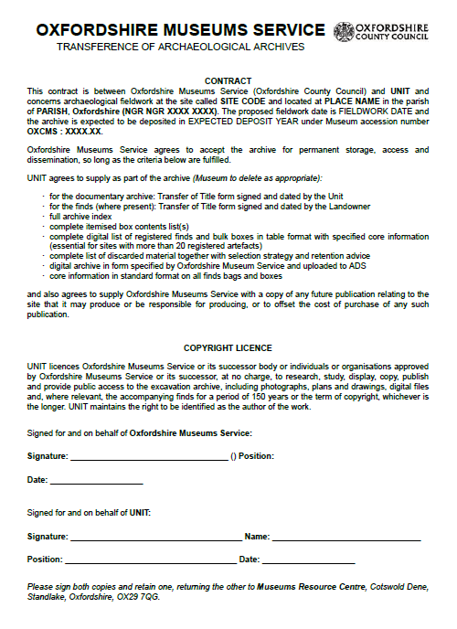

###### Appendix 5 – Price List

**Box Charges for Depositing with the Oxfordshire Museums Service**

Deposit prices from 1st April 2 022 to 31st March 2023 will be £110 (excl VAT) for any deposit.

*This fee includes the deposit of three boxes/plan rolls (any combination of document box, finds box or plan roll). For archives of more than three boxes, this will cover the three most expensive items (This applies to standard sized items, not oversized items) and additional boxes will be charged as below:*

|  |  |  |
| --- | --- | --- |
| **Finds box deposit charges\*** | Wire stitched acid free archival quality cardboard boxes, with lids with a depth of at least 75 mm. (external dimensions) | excl VAT |
| **Full Box (1)** | *0.4 x 0.25 x 0.22 m = 0.022m3  (c. 22l)* | £72.00 |
| **Half Box (2)** | *0.4 x 0.25 x 0.11 m = 0.011m3 (c. 10l)* | £36.00 |
| **Quarter Box (3)** | *0.4 x 0.125 x 0.11 m = 0.0055m3 (c. 5.5l)* | £18.00 |
| **Eighth Box (4)** | *0.2 x 0.125 x 0.11 m = 0.00275m3 (c. 2.75l)* | £9.00 |
| **Sixteenth Box (5)** | * 1. *x 0.125 x 0.11 m*   *x 0.63 x 0.11 m = 0.001375m3 (c. 1.4l)* | £4.50 |
| **Skull Box = ½ Box** | *0.2 x 0.2 x 0.25 = 0.012m³ (c. 12l)* | £36.00 |
| **Human bone = 1¾ Box** | *0.6 x 0.25 x 0.25 = 0.039m³ (c. 39l)* | £108.00 |
| **Map Rolls** | *per 100 grams* | £1.52 |
|  | | |
| **Archive box deposit charges** | Hinged lid acid free archival flat document cases | excl VAT |
| **Full Box (1)** | *0.4 x 0.075 x 0.27m = 0.0081 m3* | £26.50 |
| **Half Box (2)** | *0.4 x 0.045 x 0.27m = 0.0049 m3* | £16.00 |

**\*** *Non-standard boxes will be charged to the nearest standard box size.*

Please note all our standard box sizes are kept on file by *G Ryder & Co Ltd.* Other suppliers can be used.

**\*** *Non-standard boxes will be charged to the nearest standard box size*

## Please note all our standard box sizes are kept on file by the following manufacturers:

## *G Ryder & Co Ltd*

Other suppliers can be used. See appendix 9.

###### Appendix 6a – Transfer of Title Form for Documentary Archive

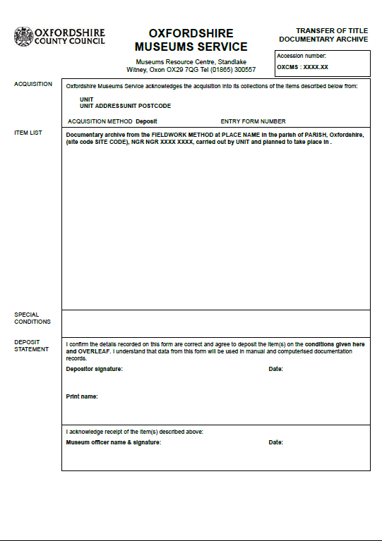

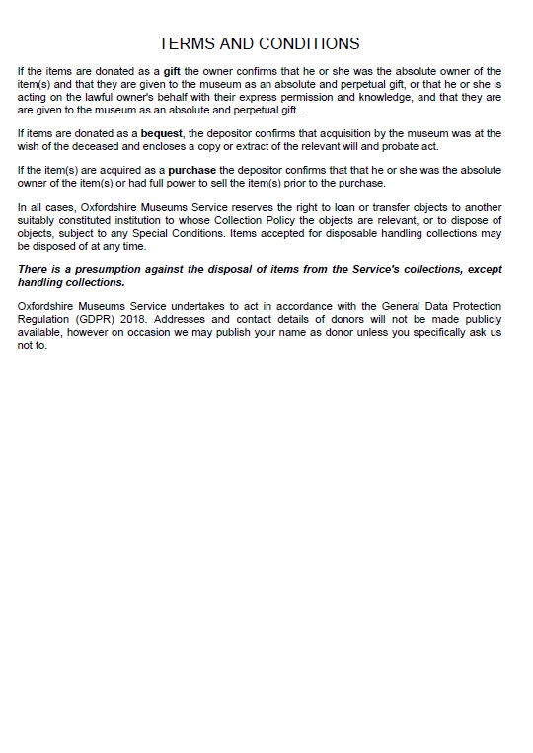

###### Appendix 6b – Transfer of Title Form for Finds Archive

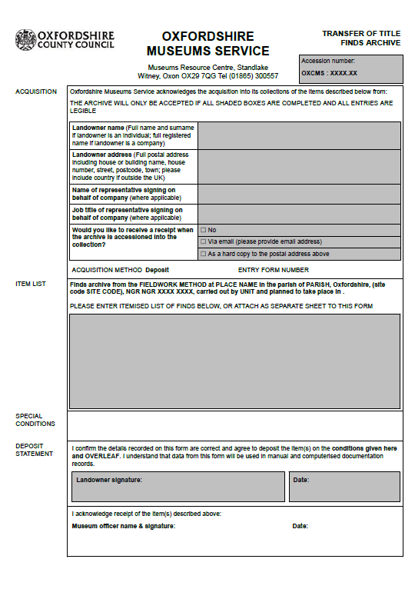



###### Appendix 7

## Sample spreadsheet file for recording finds information

|  |  |  |  |  |  |  |  |  |
| --- | --- | --- | --- | --- | --- | --- | --- | --- |
| **Site Code** | **Box no.** | **Context** | **Object no.** | **No. of items** | **Weight (g)** | **Material** | **Date** | **Simple Name** |
| BISMR 02 | Fe1 | 4008 |  | 1 |  | iron | unknown | nail |
| BISMR 02 | Ca1 | 5008 | 1 | 1 |  | copper alloy | Romano-British | brooch |
| BISMR 02 | M1 | 1 |  | 1 | 19 | animal bone | unknown | animal bone |
| BISMR 02 | F1 | 303 | 320 | 1 | 20 | flint | undated prehistoric | worked flint |

## The same file in CSV format

“Site Code”,”Box no.”,”Context”,”Object no.”,”No. of items”,”Weight (g)”,”Material”,”Date “, ”Simple Name”

“BISMR 02”,”Fe1”,”4008”,”“,”1”,”“,”iron”,”unknown”,”nail”

“BISMR 02”,”Ca1”,”5008”,”1”,”1”,”“,”copper alloy”,”Romano-British”,”brooch”

“BISMR 02”,”M1”,”1”,”“,”1”,”19”,”animal bone”,”unknown”,”animal bone”

“BISMR 02”,”F1”,”303”,”320”,”1”,”20”,”flint”,”undated prehistoric”,”worked flint”

##### Appendix 8

## Required information for bulk boxes and finds bags:

examples of labelling on boxes and on bags for pottery, animal bone, human bone, flint (all boxes and bags must display the site code and the museum accession number).

Please follow the diagrams on the following pages for labelling instructions.

|  |  |  |
| --- | --- | --- |
| BULK BAG |  | BULK BAG |
|  |  |  |

|  |  |  |
| --- | --- | --- |
| MHC 88 (C. 200=300) BONE, ANIMAL  PIG, SHEEP, DOG **OXCMS:1989.58.B3** |  | MHC 88 (C.200=300) POTTERY  ROMAN **OXCMS:1989.58.P3** |
|  |  |  |
|  |  |  |
|  |  |  |
| **SEPARATOR BAGS WITHIN BULK BAG FOR SPECIALIST  IDENTIFIED PIECES** |  | SMALL FINDS BAG |
|  |  |  |
| MHC 88 ( C. 220) POTTERY SAMIAN 3RD. C. decorated ware **OXCMS:1989.58.P3** |  | MHC 88 ( C. 250) <5> BONE COMB FRAGMENT 4TH C.  **OXCMS: 1989.58.sf5** |
|  |  |  |

## Bulk boxes

|  |  |  |
| --- | --- | --- |
|  |  |  |

|  |  |  |  |  |
| --- | --- | --- | --- | --- |
|  | | |  |  |
| **MARCHAM MHC 88  HITCH COPSE POTTERY (C.350=400)  OXCMS:1989.58.P6** | | |  | FULL BOX |
|  | | |  |  |
|  | | |  |  |
|  | | |  |  |
| **MARCHAM MHC 88  HITCH COPSE POTTERY (C.350=400) OXCMS:1989.58.P7** | | |  | HALF BOX |
|  | | |  |  |
|  | | |  |  |
|  |  | |  |  |
| **MARCHAM  HITCH COPSE SHELL OXCMS:1989.58.S** |  | |  | QUARTER BOX |
|  | | |  |  |
|  | | |  |  |
|  | | |  |  |
| **MARCHAM MHC 88 HITCH COPSE  OXCMS:1989.58.A3** | | | | FULL SIZE ARCHIVE BOX |
|  | | |  |  |
|  | | |  |  |
|  | | |  |  |
|  | | |  |  |
| **MARCHAM MHC 88 HITCH COPSE OXCMS:1989.58.A4** | | | | HALF SIZE ARCHIVE BOX |
|  | |  | |  |
|  | |  | |  |
|  | |  | |  |
| **MARCHAM  HITCH COPSE IRON FINDS  OXCMS:1989.58.I** | |  | | STEWART BOX |
|  | |  | |  |

|  |  |  |
| --- | --- | --- |
|  |  |  |

###### Appendix 9

## Some suppliers of conservation-standard boxes, bags, photographic carriers and supplies

## Silica Gel

|  |  |  |
| --- | --- | --- |
| Baltimore Innovations Ltd  Innovations House Jacksons Business Park Wessex Road, Bourne End Buckinghamshire SL8 5DT |  | 01628 531900  01628 531100  website@baltimoreinnovations.com  [www.baltimoreinnovations.com](http://www.baltimoreinnovations.com) |
| Gee-Jay Chemicals Ltd  GeeJay Chemicals Ltd. 1 Beamish Close Sandy Bedfordshire SG19 1SD |  | 01767 682774  sales@geejaychemicals.co.uk  [www.geejaychemicals.co.uk](http://www.geejaychemicals.co.uk) |

**Humidity Strips**

|  |  |  |
| --- | --- | --- |
| Conservation Resources UK Ltd (Document boxes only)  Building 345, Heyford Park Upper Heyford  Bicester OX25 5HA |  | 0**1869 377940**  email: sales@conservation-resources.co.uk  web <http://www.conservation-resources.co.uk/> |

**Cardboard boxes for bulk finds and document archives**

|  |  |  |
| --- | --- | --- |
| CBS South Ltd  Manor Trading Estate  Benfleet  Essex  SS7 4PS |  | 01268 565656  [enquiries@cbspackaging.co.uk](mailto:enquiries@cbspackaging.co.uk)  <http://www.cbspackaging.com/> |
| G Ryder & Co Ltd  Denbigh Road  Bletchley  Milton Keynes  MK1 1DG  Conservation Resources UK Ltd (Document boxes only)  Building 345, Heyford Park Upper Heyford  Bicester OX25 5HA |  | 01908 375524  [sales@ryderbox.co.uk](mailto:sales@ryderbox.co.uk) [www.ryderbox.co.uk](http://www.ryderbox.co.uk)  0**1869 377940**  ales@conservation-resources.co.uk  <http://www.conservation-resources.co.uk/> |

**Cell-Aire Foam and General Packaging**

|  |  |  |
| --- | --- | --- |
| Preservation Equipment Ltd  Vinces Road  Diss  Norfolk  IP22 4HQ |  | 01379 647400  01369 650582  [www.preservationequipment.com](http://www.preservationequipment.com) |

**Plastazote**  01732 864310

|  |  |  |
| --- | --- | --- |
| Kewell Converters Ltd  KCL House (by Esso Petrol Station) Station Road Edenbridge Kent  TN8 6HL |  | 01732 865 206  [sales@kewell-converters.co.uk](mailto:sales@kewell-converters.co.uk)  [www.kewell-converters.co.uk](http://www.kewell-converters.co.uk) |
| Polyformes Ltd  Cherrycourt Way, Stanbridge Road  Leighton Buzzard  Bedfordshire  LU7 8UH |  | 01525 852444  01525 850484  info@polyformes.co.uk  [www.polyformes.co.uk](http://www.polyformes.co.uk) |

**Polyester Sleeves**

|  |  |  |
| --- | --- | --- |
| Secol Ltd  Howlett Way  Thetford  Norfolk  IP24 1HZ |  | 01842 752341  01842 762159  [www.secol.co.uk](http://www.secol.co.uk) |

Also: **Conservation Resources Ltd** (above), **Preservation Equipment** (above)

**Phenoxyethyl**

|  |  |  |
| --- | --- | --- |
| Nipa Laboratories Ltd  Llantwit Fardre  Pontypridd  Mid Glamorgan  CF38 2SN |  |  |

**Plastic Boxes**

|  |  |
| --- | --- |
| Stewart Plastics Ltd  Beaumont Road  Banbury  Oxon  OX16 1RH | info@stewartcompany.co.uk  <http://www.stewartcompany.co.uk/> |

Past Horizons 01620 861643  
Old Schoolrooms [info@pasthorizons.com](mailto:info@pasthorizons.com)  
Luggate Burn [www.pasthorizonstools.com/default.asp](http://www.pasthorizonstools.com/default.asp)  
Whittingehame   
East Lothian  
EH41 4QA

**Appendix 10 Summary Spreadsheet of Archive boxes to be deposited.**

###### 