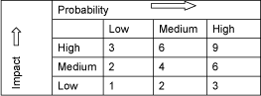

Filming Risk Assessment Form Please use the matrix to calculate risk

Event Name: |  | Date: |  | Venue:

(1)  Activity /  Area of Concern  i.e.: what is taking place as part of the event? | (2)  Hazards Identified  i.e.: what can cause harm? | (3)  Persons at Risk  i.e.: who could be harmed by the hazard? | (4)  Current Risk Factor  (high, medium or low)  i.e.: determine the level of risk | (5)  Actions to be Taken to Minimize each Risk  i.e.: what action can you take to lower the level of risk | (6)  New Risk Factor  (high, medium or low)  i.e.: risk factor after action taken to minimize the risk

Name of person completing Risk Assessment (printed): ………………………………………………………….

Signature: ………………………………………………… Date: ………………………….

