Communication Language and Literature for 0-3 years

Speech and language development - what to expect

Repetition is very important to the acquisition of language. Infants and young children need to hear words repeatedly. Some studies suggest that young children need to hear words from four to 250 times before they can accurately use them in their speech.

Children whose parents talk to them frequently have better language and vocabulary skills than those who seldom talk to them. Studies have found that the vocabulary of toddlers whose parents are talkative are measurably larger than those who offer less language stimulation.

In the first few years of life children need to learn and acquire many skills. These are mainly learned through the interaction between infant or child and their caregiver.

Skills include:

Taking turns, Waiting, Anticipation, Listening, Attention, Interacting with others, Understanding and knowledge of the world around them.

http://www.wordsforlife.org.uk/baby

Receptive language development

0-3 months
Responds to loud sounds
Recognises your voice

4-6 months
Looks toward sound
Attends to toys with sound and music

7-12 months
Enjoys routine predictive games (i.e. peek-a-boo)
Recognises words from common items
Begins to respond to simple requests (i.e. “come here”)

12-18 months
Understands 100-150 words in context
Points to body parts
Listens to songs, stories, rhymes

18-24 months
Understands 150-200+ words
Follows simple commands
Understands simple questions
Identifies pictures in books by pointing

24-36 months
Understands 200-500+ words
Follows 2-step directions
Understand one, all, in, on, under,
Understands differences in meaning (i.e. go/stop),
Starts to understand many aspects of language including grammar
Listens to longer stories

Expressive speech, language and social development

0-3 months
Cooing
Different cries for different needs
Smiles when spoken to/sees you

4-6 months
Babbling sounds (p, b, m)
Laughs
Vocalizes pleasure/displeasure

7-12 months
Varied babbling
Uses speech/sounds to get attention
Imitates speech sounds
Produces first meaningful word

12-18 months
Uses gestures for intentional communication
Uses many different consonant sounds
Rapid increase in vocabulary daily

18-24 months
Says 50-150 words
Names common items
Starts to put 2 words together

24-36 months
Says 100-250+ words
Uses 2- 4word phrases
Uses sounds (k, g, f, t, d, n)
Requests objects by name
Starts to use grammar rules of language

Communication and language development are about more than talking. It means all the different ways a child understands and communicates, only part of which are spoken words.

How can I improve my baby's communication skills?

This takes time and attention to develop a good two-way communication.

Here are some ideas to help your baby or toddler develop communications skills:

1.Respond to your baby's gestures, looks and sounds. ...
2.Talk with and listen to your child. ...
3.Help children build on their language skills. ...
4.Teach your child about non-verbal communication. ...
5.Respect and recognise your child's feelings.

Encourage baby's early attempts to communicate with you with loving attention:

- Smile often at your baby, especially when he is cooing, gurgling, or otherwise vocalizing with baby talk.
- Look at your baby as he or she babbles and laughs, rather than looking away, interrupting, or talking with someone else.
- Smile, talk, sing, and read to your baby.

Why focus on communicating with your baby?

Because early speech and language skills are associated with success in developing reading, writing, and interpersonal skills, both later in childhood and later in life.

At what age does literacy development usually begin?

During early speech and language development, children learn skills that are important to the development of literacy (reading and writing). This stage, known as emergent literacy, begins at birth and continues through the preschool years.

Research shows that early reading experiences, opportunities to build vocabularies, and literacy rich environments are the most effective ways to support the development of pre-reading and cognitive skills that ensure that children are prepared for success in school, and throughout life.

Early Literacy is what children know about reading and writing before they actually read or write. ... Research shows these early literacy skills are best developed through talking, singing, reading, writing and playing. Beginning at birth, what you do every day helps prepare your child to become a successful reader.

Six Early Literacy Skills.
Young children need a variety of skills to become successful readers. ..
.
• Vocabulary. ...
• Print Motivation. ...
• Print Awareness. ...
• Narrative Skills. ...
• Letter Knowledge. ...
• Phonological Awareness.

Children develop early literacy skills when you give them the chance to play with and explore books and other written materials like magazines, newspapers, take-out menus, markers, and crayons.

Read lots of books with your child.

Reading together helps your baby develop a love of reading. It also helps her learn the skills to read books (such as turning the pages, reading the words, talking about the pictures). Reading aloud also nurtures your child’s language and listening skills.

. Recognise that not all books are winners

Toddlers have strong likes and dislikes. Follow your child’s lead and let her decide which books to read. Forcing a child to hear a story does not build a love of literacy.

“Read” the world around you.

Point out stop signs, open/closed signs, your street sign. Let your child play with and “read” all kinds of written material—magazines, newspapers, catalogues, take-out menus, food labels.

Let them move and keep reading.

Children are often still listening even as they move around. In fact, some children, who have a strong need to be on the move, listen better when they are in motion!

Encourage your child to act out the story you are reading eg, you can ask him to jump like the frog in the book.

Tell your child a story

Instead of reading a book, tell your child a story. Children still gain important literacy skills by listening. They learn new words. They also learn how a story unfolds in a sequence (beginning, middle, and end).

Let your child help “read” the book.

Let your child hold the book and turn the pages. This helps her learn how a book works. See if she would like to read to you in whatever way she likes. She may want to point to the pictures and have you say what they are. Or she may babble as she “reads” the words on each page.

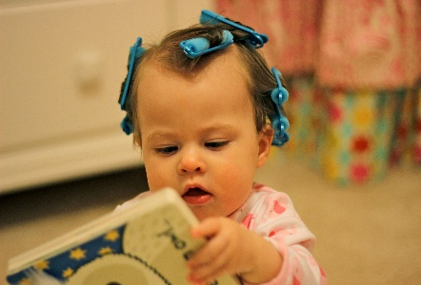
Early writing

For very young children, art and early writing skills are one and the same. At first, it’s all about just figuring out what crayons can do. Then your child discovers the link between her hand holding the crayon and the line she made on the page: cause and effect. This leap in thinking skills is helped along by her new ability to hold things in her hands and fingers. The growing control your child has over the muscles in her hands lets her move a marker or paintbrush with purpose and with a goal in mind.

Young children need to experience large body movements to strengthen muscles in arms and hands ready for writing. Large mark making opportunities with chalk, paint, crayons etc help to build these muscles.

Hand and finger muscles can be strengthened through the use of gloop, playdough, and clay; and children can be encouraged to use fingers to draw in sand, sawdust and paint, ready for future more formal writing experiences.

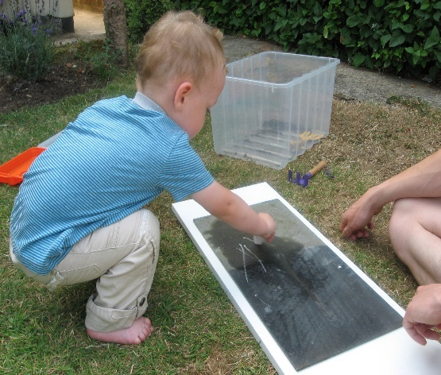

For very young children, there are four stages of drawing and writing that you may see as your child grows from 15 months old to 5 years old. Growth doesn’t happen at the same speed for every child, but by offering repeated fun experiences with a variety of art and writing materials, you will see progress over time.

Stage 1: Random Scribbling (15 months to 2½ years)
Stage 2: Controlled Scribbling (2 years to 3 years)
Stage 3: Lines and Patterns (2½ years to 3½ years)
Stage 4: Pictures of Objects or People (3 years to 5 years)

Give your child a wide range of creative experiences to build these skills. Remember it is the process and not the product which is important.

Children need to see writing modelled, so that they understand there is a reason to write and therefore are encouraged to try. Displaying children’s mark making and creative productions is a good way to validate the experience and make your child feel proud of what they have achieved.

