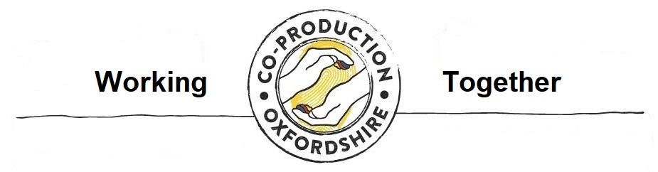

DOING CO-PRODUCTION:

Self-reflection Form
At the end (of a session, workshop, or project, etc)

What went well?

What could have been better?

How do I know for sure that…

- people understood why they were there?

- people understood the task?

- people felt meaningfully involved?

- people felt equal?

Was I as open, honest and transparent as possible? If not, why?

Who are the groups of people that are affected by this project?

Who, out of those groups or people, are involved in this project?

Self-reflection Form cont’d…

If any of those groups or people are not involved, what
prevented them?

Did anything stop people from participating fully and/ or in a meaningful way? If so, why?

How was decision-making shared in the group?

Have I asked people for their feedback?

How would I rate my facilitation skills?

How did I handle any conflict, or prepare for handling it?

What have I learned?

What would I do differently next time?

What do I think people are saying about this?

What would I keep the same?

What would I say to someone else who was about to start the co-production journey?

Use and Creative Commons license:
The content of this handbook is copyrighted under the Creative Commons Licence CC-BY. This means that you can distribute, remix, tweak and build upon this work, even commercially, as long as ‘Co-production Oxfordshire, funded by Oxfordshire County Council’ is credited for the original creation.

