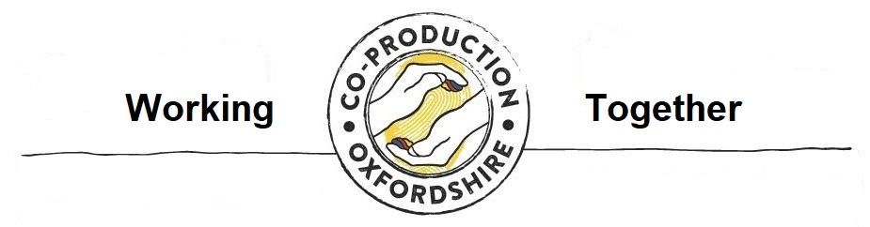

DOING CO-PRODUCTION:

The Practicalities

It is always best to make a co-production plan before you start.

Use these guide sheets with the following ‘Doing co-production’ sections to help with your planning and thinking:
- Barriers
- Lifting the Barriers
- Some Useful Tips, Reminders and Advice
- Making Things Accessible
- Grab Sheets: Good Co-production Recipe
and Mind Your Language

Note there are two guide sheets here:
- At the start
- Planning meetings and workshops

and a
- Managing meetings and workshops: Getting it right from the start – key essentials

section at the end.

AT THE START

Getting started: Motive and Scope
What is the project?

Why is it happening (what is the reason for the change?)

How much time do I have to do it?

Is there a request for it to be co-produced? If so, by whom?

Who do I know who has done co-production, and can help me with it?

Can the project realistically be co-produced within the time-frame I have been given?
(The time needed for projects will vary depending on the nature and scale of the project, but we would suggest anything less than 6-12 months is not enough. Talk it through with the person/ people you have identified above if you are not sure)

(If not, STOP. And either:
- take this back to your manager with a request for more time OR
- accept (and have it agreed) that it won’t be a fully co-produced piece of work, but please don’t let this put you off from involving people as much as you can in the timeframe you get given)
Can all aspects of the project be co-produced or just some?

If not all, why not?
If not all, which aspects should be, to bring most value to the project and people involved?

(Talk this through with the person/ people you have identified above if you are not sure.)
If there is enough time for the project to be co-produced:

Do I have support from management to co-produce this project?

What barriers/ challenges do I think there will be along the way?

Do I know my organisation’s policies and procedures around:

- Remuneration (paying/ reimbursing people)
- GDPR
- Equality and Diversity
- Service and community Impact Assessments (SCIAs)
- Demographic monitoring
Budget, Legal Factors and Governance

Do I have a budget for this project?

Where will the money for paying for people’s expenses and time come from?

Are there any other projects (current or coming up) that are likely to impact on mine?
Are there any legal issues that may affect the project? (e.g. Purdah or formal consultations that might have an impact, for Council staff)
Do I know the law around consultation for this project (e.g. Gunning Principles/ Public Sector Equality Duty, etc)?
Does anything need sign off/ management approval before I can continue?

It is really important to be clear what needs signing off, by whom, and when
(e.g. even down to things like whether the right logos are being used)
Getting the Right People Along

Who does the project affect, i.e. who do I need to involve (stakeholders)?

Think:
- People using/receiving services
- Families
- Carers
- Members of the public
- Colleagues
- Other professionals/ organisations
etc

Ask a colleague in engagement, or who holds data information, to help you.
Have I done in-depth stakeholder mapping, e.g. considering levels of influence different groups/ people have (stakeholder analysis)?
How am I going to make contact/ reach/ find each of the groups/ individuals that need to be involved?
Who can help me with this? (e.g. colleagues, internal/ external communications teams, community leaders, other organisations, etc)

Representation and Involvement

How am I going to make sure I have wide enough representation of each group?
What will the needs of people involved be?

What do I need to do to make sure people will be able to take part fully and in a meaningful way?
Will any training for participants be required? (e.g. if involved in recruitment/ interview panels, they will need relevant training)
What do I need to do to make information accessible to the people involved?
What do I need to do to make meetings and workshops, etc accessible for people?
Am I being creative enough in thinking about how people can get involved?

Apart from running meetings and workshops, etc, what other opportunities am I providing for people?

(Ideally, everyone would be in the same place at the same time, but this is not always appropriate or realistic.)

Can I go and visit people if necessary?
How can I involve people every step of the way? (e.g. having people using services attend and present at key decision-making meetings, etc)
Have I missed anyone who should be involved?

(Keep asking yourself, ‘Who should be involved in this?’)

Do I know enough about suitable/ accessible meeting venues? If not, how can I find out?
Timing and Communication

Timeline- what needs to happen when?

Does my timeline give people enough notice to be able to attend any meetings, workshops or other sessions? (minimum of 4 weeks recommended)
Does my timeline/ plan allow for proper relationship-building?

What will people need to know in any initial communication?
E.g.:
- Nature of the project
- How it affects them
- Timeline/ key dates
- How they can get involved
- If meetings or workshops being planned- timings, length, food and refreshment provision
- Commitment required
- Role description (if applicable)
- Training requirements and provision (if applicable)
- Remuneration/ payment details
What will my process be for bringing together all contributions made?

How will I feed this information back to all the relevant people?

Am I communicating in a language that is accessible, respectful and helps people want to be involved?
Finally…

Have I made assumptions about anything?

Time to reflect…

Check your thinking/ planning through with someone who knows about co-production.

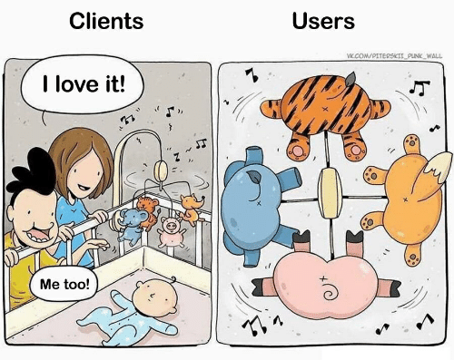

[source vkcom Peterskii: https://me.me/i/clients-users-vk-com-piterskii-punk-wall-i-love-it-me-too-9a055d6e42b4431087ca9bc800b5e4d5]

PLANNING MEETINGS AND WORKSHOPS

Practical matters (venue, catering, resources)

Have I booked the venue?

Is it appropriate/ accessible?

Check e.g.:
- wheelchair access
- parking
- lighting
- acoustics
- loop system
- public transport links
- geographical location (in relation to group)
Do I need to do an activity risk assessment?

What is the process for people being paid expenses and for their involvement?
What needs to happen to make sure this is done? (e.g. who deals with payment and claim forms?)
What staffing resources will I need?

What other resources will I need? (stationary, etc)

What forms/ paperwork will I need?
e.g.
- Remunerations policy
- Claim forms
- Media consent forms
- Consent forms (for data storage)
- Feedback forms
- Copies of agenda
- Copies of any previous minutes
- Copies of any documents people will need to refer to
Will lunch be provided? Who by? What needs to happen?

We advise to always provide food for people if you can. It makes all the difference!
Accessibility and Involvement

Have I given people enough notice to be able to attend? (minimum of 4 weeks recommended)
How will I make sure everyone in the session has the chance to participate?

Do I know/ have I asked people what they need? For example, in relations to:

Mobility
Communication methods
Dietary requirements
Reminders
How am I making sure these needs will be met?

What participatory tools will I need? (e.g. turn-taking cards, inclusion forms, etc)

(See ‘Doing co-production: Making things Accessible’ section for some links to good resources)
Is anyone joining remotely (e.g. Skype, conference calling in)?

If so, what do I need to enable this to happen?
What information do I need to send participants in advance?
Has this been produced in a format that is clear and accessible for all? (several formats may need to be produced)

When does this need to be sent?

People need time to absorb and understand information in order to be able to participate meaningfully.
Managing the session(s)

Note: Setting the scene in meetings and workshops and creating the right atmosphere for constructive and supportive working right at the start is crucial. It makes all the difference to how well a group is likely to work together and can go a long way in helping to manage any difficult challenges later on.

By right atmosphere, we mean one in which trust is built and where people feel:
- safe (e.g. to express their views/ to disagree with others and be disagreed with)
- respected as individuals
- heard
- valued
- equal

In addition to completing the questions below, make sure you read the ‘Managing meetings and workshops: Getting it right from the start – key essentials’ section that follows this form.

Do not underestimate the importance of establishing and following these essentials. We cannot emphasise enough the difference they can make between a session being unproductive, negative and even unpleasant for people rather than a constructive and positive experience.
Do I feel experienced enough to facilitate, manage expectations, and manage any conflict that arises?

If no, or not sure, is there time to do some training, or can I get support from an experienced facilitator?
(Note: For Oxfordshire County Council staff, we recommend doing the ‘Facilitation Skills’ and ‘Unconscious Bias’ e-learning, and the
‘Doing Co-production’ training run by
Co-production Oxfordshire.)

How will I ensure best use of time?

How will I make sure we keep to time?

In the first session…

Group to agree ways of working together (‘agreements’/ ‘ground rules’), and these to be written down.

Re-visit ‘agreements’ at the start of every session – check people are still happy with them; make any necessary changes.

(See ‘Doing co-production: Example Agreements for meetings’ for an example of what agreements might look like. But use this as a prompt only if people are stuck for ideas; it’s important that agreements are not set by the meeting facilitator but produced collaboratively and owned by the group.)
How am I going to establish a level playing field between everyone in the group?
How will I check people have understood the information?
(Never make assumptions… A common error is asking “Does everyone understand?” and when they say yes, moving on. Small group activities are best for helping people understand their role and the purpose of any workshop or meeting.)
How do I think I will deal with differences in opinion within the group? How will we reach an agreement?

(This is difficult to plan for as each group will be different, but it is still helpful to think about.)
For tools to facilitate meetings and workshops, see:

https://seedsforchange.org.uk/tools

https://seedsforchange.org.uk/resources

https://seedsforchange.org.uk/activelistening

https://seedsforchange.org.uk/facilitationmeeting

https://seedsforchange.org.uk/shortfacilitation

Feedback and Learning

What will my feedback process be (to the people involved)?

How will I make sure people are kept informed and up-to-date?

It is critical to keep people informed. Relationships you have built break down very quickly if people feel ignored or used.
Have I left enough time in the day for people to give feedback?

Explain to people why feedback is important (e.g. helping you to learn and improve) and what will happen to it.
How will I gather feedback from the people involved?
(You can use or adapt the Participant Feedback Form. There are two versions: Easy Read and non-Easy Read.)

Consider providing a closed box for feedback forms to encourage honesty.
What will I do with this feedback?

e.g.
- where does it need to go?
- who needs to see it?
- how will I learn from it?
- how will it be used to inform future practice?
- where will it be stored? (remember GDPR)

Tip: people involved do want to know what the general feeling was, so share it with them.

How will I reflect on the process and what I have done?

(You can use the Self-reflection Form)

Managing meetings and workshops:
Getting it right from the start

Key essentials

In our experience, in order to manage meetings and workshops successfully and create the right atmosphere for constructive and supportive ‘working together’, the following things must be established at the very beginning and re-visited/ applied on each occasion.

- Language - keep
it simple, keep it ‘human’: no acronyms, no jargon, no services ‘special speak’ (see ‘MIND YOUR LANGUAGE: Grab Sheet’).

- Bring your whole self to the group: don’t be afraid to say how you feel or give people a bit of insight into you as a person.

- Create an atmosphere of equality: don’t wear lanyards; don’t power dress; be a real person and not just a professional; introduce yourselves by saying the area you work in and not your job title; if running the session with colleagues, try and dot yourselves around the room so you are not all grouped together.

- Access needs: check that everyone in the room has what they need to be able to participate fully.

- Take turns to speak: use turn-taking cards, hands-up, etc; have a strong Chair/ facilitator who manages the conversation well.

- Establish ground rules/ agreements: for the way people will conduct themselves and treat each other in the session. Make sure everyone present is involved in this so they sign up to and own what is agreed. Agreements need to be directly linked to the principles of co-production (e.g. treating each other with respect, as equals, etc) and not just about practicalities (like switching off your phone).

- Establish the goal/role of the group: ensure everyone present is involved in this, and all understand why they are there and what direction you are all going in.

- Establish the values and purpose of co-producing: everyone present needs to understand these values as they underpin the goals. Have copies of the co-production principles available; re-visit at the start of meetings; anchor conversations, decisions, etc in these principles.

- Establish shared definitions/ meanings: don’t assume everyone has the same understanding of a word or phrase (like co-production!) Where possible, work out a shared definition as a group; where this cannot happen, be clear what definitions are being used. Once a definition has been agreed/ presented, have it available as a reminder and point of reference for people in each session.

- Use a ‘car park’/ ‘parking lot’: record any issues/ items (e.g. on flip chart paper) that come up in the meeting that are not directly relevant to the session at that time, or that cannot be addressed at that time. This helps keep meetings on track and to time, whilst also valuing and recognising what people have raised. Invite anyone to add to the car park; use it as a collaborative, self-moderating tool for the group. Be clear about what will happen to the points on the car park…how will they be addressed/ followed
up on?

- Be open and honest: about limitations, what influence people can actually have, what can’t be changed, what you do and don’t know (it’s okay not to have all the answers but make a note of any questions and let people know you’ll do your best to find out).

- Check everyone understands what is going on: not by asking ‘do you understand’, but by trying to get people to say what it is they have understood (this needs to be done sensitively though so people don’t just feel patronised).

- Follow up on feedback and actions: as quickly as possible and keep people informed of what’s happening, every step of the way.

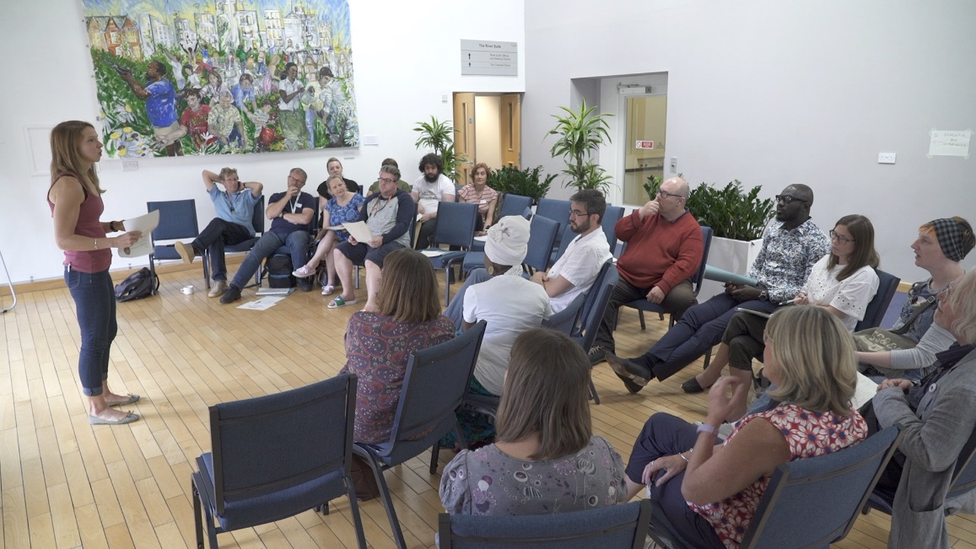

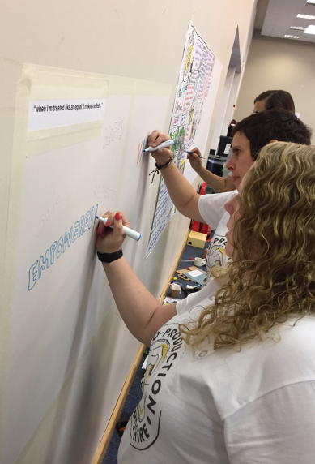

- Make no assumptions: ever, about anything!

Use and Creative Commons license:
The content of this handbook is copyrighted under the Creative Commons Licence CC-BY. This means that you can distribute, remix, tweak and build upon this work, even commercially, as long as ‘Co-production Oxfordshire, funded by Oxfordshire County Council’ is credited for the original creation.

