PARTICIPANT FEEDBACK FORM

- How satisfied were you with this event?

Very Satisfied Very dissatisfied
5 | 4 | 3 | 2 | 1

- Were you able to take part in the discussion and have your say?

Yes, very much so No, not at all
5 | 4 | 3 | 2 | 1

- Did anything stop you from participating fully? If so, what?

- What was good about the session/ workshop?

- If you were running this session yourself, what would you do differently?

- What could we do differently to improve future sessions?

Participant feedback form cont’d…

- Anything else you’d like to tell us?

Thank you for completing this form. You do not have to tell us who you are. If you would prefer to remain anonymous, please do not fill in your name here.

Name:___________________________________________________

Organisation (if relevant)_____________________________________

I use services ☐ I am a carer ☐

Consent for using your feedback

We may want to use your feedback in our project or programme evaluation, which will be publicly available. Do you give consent for us to quote you anonymously, for example, in reports and evaluations and on our website?

Yes ☐ No ☐

Signed_______________________Date________________________

If you change your mind about the consent you have given, please contact us to let us know. Email [insert email address] or call [insert telephone number].

PARTICIPANT FEEDBACK FORM
(Easy Read)

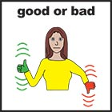  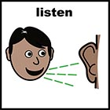 | Did you feel listened to today?
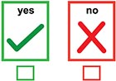

 | Did you find it useful?
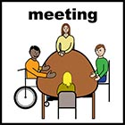 | What did you like about the meeting?
 | What didn’t you like about the meeting?
 | Anything else you would like to tell us?

Your name (you do not have to tell us if you would prefer not to)
Date

Use and Creative Commons license:
The content of this handbook is copyrighted under the Creative Commons Licence CC-BY. This means that you can distribute, remix, tweak and build upon this work, even commercially, as long as ‘Co-production Oxfordshire, funded by Oxfordshire County Council’ is credited for the original creation.

